Farouk El-Baz Centre For Sustainability and Future Studies (FECSFS)
  - Established March 2011
  - Research Center’s Annual Review 2019
  - Reporting Period May 2018 – April 2019

Centre Director: Prof. Ahmed Yehia M.G Rashed
Associate Director: Dr. Marwa Adel El-Sayed

TABLE OF CONTENTS
1. Executive summary 3
2. Human Resources 6
3. Physcial Resources 13
4. Publications 14
5. Research Grants 31
6. Patents 36
7. Technology Transfer 52
8. Community Engagement 65
9. Colloboration 105
10. Center Activities 106
11. Finance 116
Annex 117

1. Executive summary
The idea of establishing Farouk El-Baz Center for Sustainability and Future Studies (FECSFS) at the British University in Egypt started in 2008 to encourage research and scholarship in sustainable development. It ran as a unit within the Department of Architecture Engineering at the time. We organized the "Future Intermediate Sustainable Cities" (FISC) in November 2010. Shortly after that, the unit became a university center in March 2011. FISC delivered a futuristic vision for how sustainable development can be included in the necessary studies and research that Egypt needs in the self-building stage. Unfortunately, FISC's recommendations were not fully utilized as they should have been. FISC was connected to a competition on sustainable future medium cities. The latter provided ideas and scenarios related to 3 dimensions from the proposed passage of development and reconstruction that was first outlined by the renowned scientist Farouk Al Baz.
The Center for Sustainability and Future studies emerged after the 2011's revolution as a Research and Development (R&D) Center at BUE. Since then, FECSFS has become BUE’s Ambassador for Sustainability and an important part of the BUE’s efforts to address future sustainability in terms of environmental, economic, and social challenges through the engagement of students, academic staff and researchers.
Today, and after past 8 years of its founding, FECSFS as a research center at BUE, has now established a substantial recognition not only within Egypt but also in China, Korea, USA, England, Italy, Germany, Jordan, Syria, UAE, and Saudi Arabia through signed MOUs and/or mutual scholarship activities. The following list highlights FECSFS’ major milestones and accomplishments:
- 2011:
  - Future Intermediate Sustainable Cities Conference
- 2012:
  - Taking Leave Competition
- 2013:
  - Luxor Workshop: Partnership, Sustainability, and the Chances
- 2015:
  - Development Olympics of Suez Canal Region
- 2016:
  - Sustainable Mega Projects (Chance -Change-Challenge) Conference
  - Farouk El-Baz Forum for Younger Generations
- 2017:
  - Green Worship House Competition, organized within collaboration with HBRC (Dr. Khaled El Zahaby)
  - Launch of the “Civilization Rights to Build Civilization” research project funded by the Egyptian Academy for Scientific Research and Technology.
- 2018:
  - Green Heritage Conference
- 2019:
  - Medical Tourism Competition
  - Civilization Rights to Build Civilization National Competition
- FECSFS has also:
  - Participated in the celebration of the 50 years anniversary of the reallocation of the Abu Simbel temples.
  - Devoted considerable effort in promoting scientific research in students’ graduation projects and encourage them to deal with the challenges of Egypt’s national issues, and to incorporate in their project’s ideas related to sustainable development.
  - Applied to STDF grants including: “The Scientific Tourism for the Human Heritage for Upper Egypt” and “The Civilization will be born from the Womb of Civilization.”
  - Developed and submitted several research proposals.
  - Actively engaged in research collaboration with several national and international organizations, both governmental and non-governmental.
  - Extensively published research in journals, conferences, books, and professional magazine.
  - Actively participated in numerous workshops and conferences both in Egypt and abroad, as well as in symposia, national and international seminars, and summer and winter schools.
  - Featured BUE’s effort on sustainability in a multitude of media outlets newspaper article, TV shows, internet blogs, etc.
  - Participated in the Cairo International Exhibition of Innovations.

During the report period of 2018/2019, FECSFS continued its efforts and activities along all the above listed dimensions. Featured activities included the following:
- Continuing to maintain our scholarly record in the form of research publication, conference presentations, and educational materials in the areas of sustainability, heritage conservation, architecture engineering, and civilization rights.
- Organizing a vast number of seminars and workshops all over Egypt, as well as in Jordan and Saudi Arabia) to introduce and educate colleagues, youth and scholars on issues related to Civilization Rights Campaign, and to prepare the launch of the competition in several places such as universities and scientific and cultural institutions.
- Participating in the 5th Cairo International Exhibition of Innovations 2018 and winning the 3rd place award of the initiative programs.
- Announcing and launching the Civilization Rights National Competition in November 2018 in collaboration with the Academy of Scientific Research and Technology (ASRT).
- Announcing a new competition for Medical Tourism in December 2019.
- Conducting campaign tours in both in the Delta and Upper Egypt regions to spread and raise awareness of the Civilization Rights to Build civilization issues in universities and educational, research and tourism institutions.
- Organizing a workshop at BUE for the contestants and judges of the Civilization Rights Competition. The workshop marked the conclusion of the first phase of the competition and the preparation of the second phase.
- Attending multiple international and conferences.
- Preparing for a tour for the Civilization Rights campaign across U.S. institutions of different types (universities, research center, museums, culture missions) in the summer of 2019.
- Entering research and collaboration agreements with over 15 entities in Egypt (universities and ministries) to support the Civilization Rights campaign.
- Signing an MOU with King Saud University to collaborate on joint research related to the development of Red Sea Basin.

2. Human Resources
2.1 Our Inspiration: Dr. Farouk El-Baz, FECSFS’s Honorary President
The center has been honored to change its name in 2016 in recognition of the legacy of Professor Farouk El-Baz’s and the contribution he made and is still making to the advancement of science and the future sustainability of planet Earth. Dr. El-Baz is a renewed Egyptian American space scientist, and Professor Emeritus and Former Director of the Center for Remote Sensing at Boston University. Dr. El-Baz has been actively supporting many FECFS activities. He has participated in several workshops and conference events organized by the center. He has provided guidance and advice on several issues including those related to his vision on the development corridor in Egypt. He has provided certificates in support of students and young scholars. He has donated 57 boxes to the center that include books, research, maps, books of his.
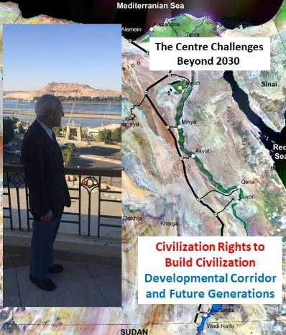
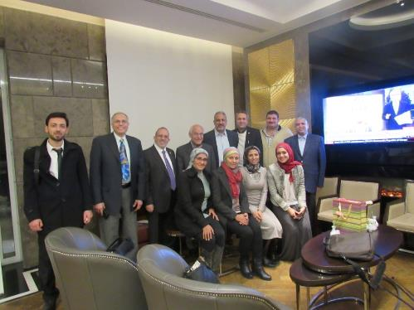
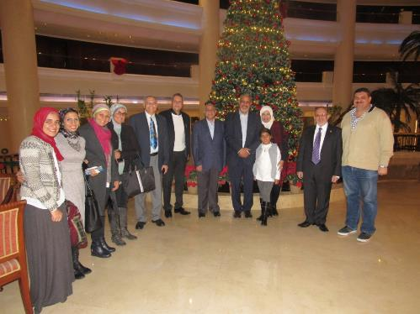
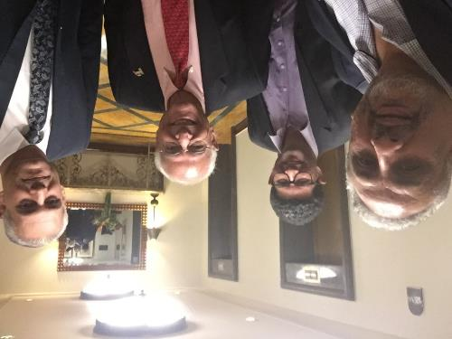
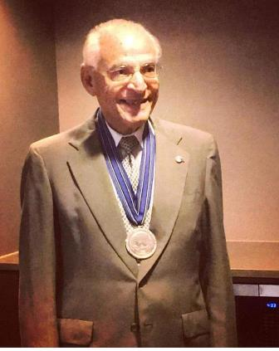 | 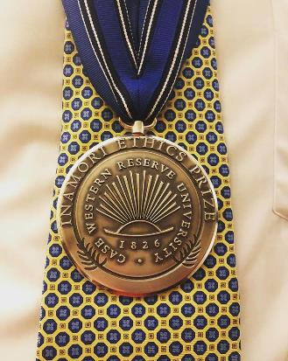
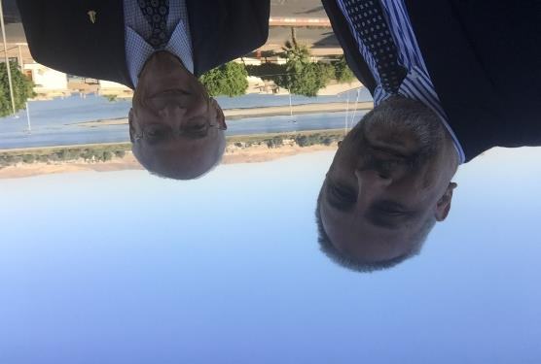
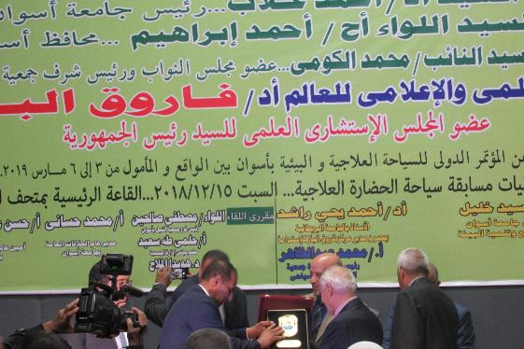
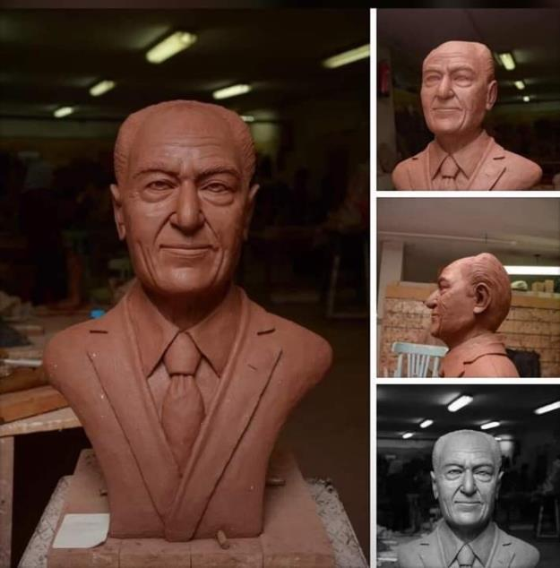

2.2 Members of FECSFS
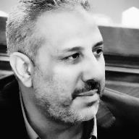 | 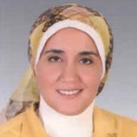
Prof. Ahmed Rashed; Founding Director of the FECSFS (engineering) | Dr. Marwa Adel; Associate Director of FECSFS (engineering)
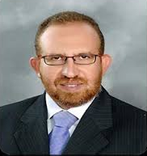 | 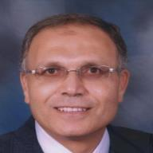
Prof. Hussam Bakr (Board Member) (engineering) | Prof. Mohamed El Attar (Board Member) (engineering)
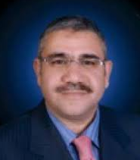 | 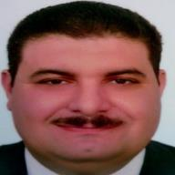
Prof. Ayman Othman (Board Member) (engineering) | Dr. Ziad Khalifa (Board Member)  (engineering)
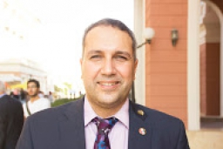 | 
Dr. Hesham Safwat (Board Member) (engineering) | Dr. Walaa Salah (Board Member) (engineering)
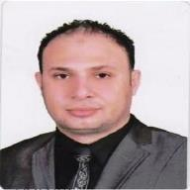 | 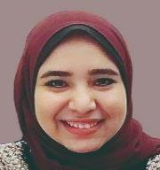
Dr. Hassan Refaat (Assistant Lecturer) | Arch. Eman Touliabah (Research Assistant)
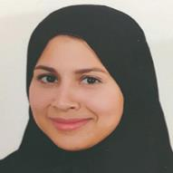
Arch. Salma Mohamed Fathi (Admin Assistant- Research Assistant)

3. Physcial Resources
Equipment’s available | Quantity | Date acquired | Funded by: | Description
Chairs | 13 | August 5th, 2018 | FECSFS budget
Sofa | 1 | August 5th, 2018 | FECSFS budget | Waiting area for doctors, students, and visitors
Disks | 3 |  | FECSFS budget | For director, secretary and research assistant of the center.
Office cubicles | 3 | August 5th, 2018 | FECSFS budget | For research assistants hired
Meeting table | 1 | August 5th, 2018 | FECSFS budget | For board members meeting.
Computers | 3 |  | FECSFS budget | For Centre Studies
Camera | 1 | 2017 | FECSFS budget | Used for Centre activities documentations
Screen | 1 | 2015 | FECSFS budget | For presentations
Prof. Farouk El-Baz boxes | 57 | 2019 | FECSFS budget | Items donated by Dr. El-Baz to the center

4. Publications
4.1. Overall publications output (March 2011 – April 2019)
Summary | Books or Book Chapters | Journals | Conferences | Other
Summary | 9 | 34 | 112 | 9

Books & Book Chapters
Professor Ahmed Rashed
Rashed, A. Y. 2011, Editor. Future Intermediate Sustainable Cities. A collection of research papers on built and natural environment sustainability issues presented in a conference held at BUE, Egypt, 2011.
Rashed, A. Y. 2016, Editor. Sustainable Mega Cities. A collection of research papers on different sustainable mega projects in different sectors including culture heritage, tourism and energy - presented in a conference held at BUE Egypt, 2016.
Rashed, A. Y. 2018, Editor. Green Heritage: Chance, Change, Challenge. A collection of research papers on green development and sustainability - presented in a conference held at BUE Egypt, 2016.
Professor Husam Bakr
Khalil, Husam (2017): HBIM and Environmental Simulation: Possibilities and Challenges. (Book Chapter) In Arayici, Yousef, Counsell, John, Mahdjoubi, Lamine, Nagy, Gehan, Hawas, Sohair, and Dewidar, Khaled (2017): Heritage Building Information Modelling. Routledge. ISBN: 978-1138645684.
Professor Ayman Othman
Conrads, S. and Othman, A.A.E. (2011). Industrialised Building Systems for Low-Cost Housing Projects: An Investigation Into their Feasibility in the South African Context. Lambert Academic Publishing. ISBN: 978-3-8433-5734-0.
Othman, A.A.E. and UKZN Research Team (1). (2011). Towards Improving Health and Safety Practices in Construction Investigating the Causes and Effects of Contractor's Non-Compliance with Health and Safety Regulations in South Africa. Lambert Academic Publishing. ISBN: 978-3-8443-0031-4.
Dr. Marwa Adel El Sayed
El-Sayed, M. A., Mahmoud, A. H. A., & El-Barmelgy, I. M. (2015). Land Suitability Analysis for Urban Green Areas Using New Methods and Techniques. Cairo, Egypt: LAP LAMBERT Academic Publishing (August 25, 2015). ISBN-10: 3659410721, ISBN-13: 978-3659410727. Retrieved from https://www.amazon.com/Suitability-Analysis UrbanGreenAreas/dp/3659410721/ref=sr_1_1?s=books&ie=UTF8&qid=1492514685&sr=1-1&keywords=land+suitability+analysis+for+urban+green+areas
Dr. Walaa Salah
Ismaeel, Walaa S.E (2016). Using SITES for Sustainable Rehabilitation of Cultural Heritage Landscape Areas, book chapter, BUE ACE1, Sustainable Vital Technologies in Engineering & Informatics, 8-10 Nov 2016, Springer International Publishing AG 2017, DOI 10.1007/978-3-319-48725-0_6, p 51-62
Dabaieh M., Kenawy I., Ismaeel, Walaa S.E. and Elsayed M., (2016). Carbon mapping for residential low carbon retrofitting, book chapter, BUE ACE1, Sustainable Vital Technologies in Engineering & Informatics, 8-10 Nov 2016, , Springer International Publishing AG 2017, DOI 10.1007/978-3-319-48725-0_9, p 79-92

Refereed Journal Papers
Professor Ahmed Rashed
Abdel Razik, Walaa and Rashed, Ahmed, 2015. Towards A Sustainable Development of Damietta: as a Coastal Intermediate City in Egypt, JES, journal of Engineering sciences, Faculty of Engineering -Aussit University vol-43, Number 06 - November 2015
D. M. Hassan, Alla Abulrahman, A. Y. Rashed 2015. Role of Cairo's Hybrid Cultural Spaces in Creating Sense of Place Attachment. In Spaces & Flows: An International Journal of Urban & Extra Urban Studies. Jun 2015, Vol. 6 Issue 2, p1-19. 19p.
Dr. Marwa Adel El Sayed
El-Sayed, M. A., & Mohamed, N. M. (2016). Ecological Threshold As An Approach for Balancing Carbon Metabolism in Cities. 43InternationalJournal of Environmental Engineering–IJEE, 3(1). Retrieved from http://seekdl.org/journal_page_papers.php?jourid=125&issueid=188
Marwa DABAIEH, KENAWY, I., SALAH, W., & El-Sayed, M. A. (2016). Carbon mapping for residential low carbon retrofitting. Advanced Technologies for Sustainable Systems. 79–91. Retrieved from https://link.springer.com/chapter/10.1007%252F978-3-319-48725-0_9
El-Sayed, M. A. (2018). Land Suitability Analysis As Multi-Criteria Decision Making To Support The Egyptian Urban Development. International Journal on: Proceedings of Science and Technology, (Resourceedings of Science & Technology), 1–11. Retrieved from http://www.ierek.com/press
Ismaeel, W. S. E., & El-Sayed, M. A. (2018). The interplay of environmental assessment methods. Journal of Environmental Assessment Policy and Management. Retrieved from https://www.worldscientific.com/worldscinet/jeapm
Elsayed, M.A., Ismaeel, W.S.E., 2019. Environmental assessment for major development projects: A case study “Qattara Depression.” J. Clean. Prod. 215, 522–533. https://doi.org/10.1016/J.JCLEPRO.2018.12.301
Professor Ayman Othman
Sirbadhoo, N, Hoyana, UN and Othman, A.A.E.(2011). Quality management for delivering sustainable construction projects in South African rural areas: the construction project manager’s perspective. Built and Natural Environment
Research Papers, Vol. 4, No. 1, pp.135-148.
Othman, A.A.E. and Abdellatif, M. A.(2011).Partnership For Integrating The Corporate Social Responsibility Of Project Stakeholders Towards Affordable Housing Development: A South African Perspective. Journal of Engineering, Design and Technology,Vol. 9, No. 3, pp. 273-295.
Othman, A.A.E. (2011a). Improving Building Performance through Integrating Constructability in the Design Process.Organisation, Technology and Management in Construction: An International Journal, Vol. 3, No. 2, pp. 333-347.
Othman, A.A.E. and Harinarain, N. (2011a). Analysis of Contractors’ Perception of Risks Related to the JBCC Principal Building Agreement in South Africa.Built Environment Journal, Vol. 8, No. 1, pp. 25-36.
Othman, A.A.E. (2011b). Constructability for Reducing Construction Waste and Improving Building Performance. Built Environment Journal,Vol. 8, No. 2, pp. 31-54.
Othman, A.A.E. and Harinarain, N. (2011b). An Investigation Into Contractors’ Evaluation of Risks Associated with The JBCC Principal Building Agreement In South Africa. International Journal of Construction Project Management and Innovation, Vol. 1, No. 1, pp. 1 -26.
Othman, A.A.E. (2012a).A Study of the Causes and Effects of Contractors’ Non-Compliance with the Health and Safety Regulations in the South African Construction Industry.Architectural Engineering and Design Management, Vol. 8, No. 3, pp. 180-191.
Othman, A.A.E. (2012b).An innovative protocol for improving the ethical behaviour of the quantity surveying profession in South Africa.International Journal of Construction Management, Vol. 12 No.3, 43-62.
Othman, A.A.E. and El-Gendawy, A. H. S. (2012). Public-Private Partnership for Lean Sustainable Development in Construction.International Journal of Construction Project Management and Innovation, Vol. 2, No. 2, 377-402.
ZainulAbidin, N., Y, Noraini andOthman, A.A.E. (2013).Enablers and Challenges of a Sustainable Housing Industry in Malaysia.Construction Innovation: Information, Process, Management, Vol. 13, No. 1, pp. 10-25.
Othman, A.A.E., Ghaly, M. and ZainulAbidin, N. (2013). Lean Principles: An Innovative Approach for Achieving Sustainability in the Egyptian Construction Industry. Organisation, Technology and Management in Construction: An International Journal, Vol. 6, No. 1, pp. 917-932.
Othman, A.A.E. (2013b). Investigating The Competency of Property Development Graduates towards Satisfying the Requirements of the Construction Industry in South Africa: The Case of The University of Kwazulu-Natal. International Journal of Construction Management, Vol. 13 No.4, pp. 75-102.
Othman, A.A.E. (2014a). A Study of the Competency Requirements of Property Development Graduates to Meet the Qualifications of the South African Construction Industry. Journal of Engineering, Design and Technology, Vol. 12, No. 1, pp. 2-28.
Othman, A.A.E. (2014b).A Conceptual Model for Overcoming the Challenges of Mega Construction Projects in Developing Countries. African Journal of Engineering Research, Vol. 2, No. (4), pp. 73-84.
Othman, A.A.E. and AboulSeoud, S.H. (2014). Constructability for Sustainability: A Waste Elimination Approach in Construction Projects. Covenant Journal of Research in the Built Environment (CJRBE) Vol. (2), No. (2), pp. 99-116.
Othman, A.A.E. (2015). An International Index for Achieving Customer Satisfaction in the Construction Industry, International Journal of Construction Management, Vol. 13, No. (1), pp. 33-58.
Othman, A.A.E. and Halim, A. S.A. (2015). Knowledge Management: A Novel Approach For
Improving The Performance Of Architectural Design Organisations In Egypt. Emirates Journal for engineering Research, Vol. (20), No. (1), pp. 1-16 (2015)
Othman, A.A.E, Balaha, F. I. H. and Fester, F. (2015). Using Risk Management In The Re-Design Process For Re-Use Of Existing Buildings. Journal of Construction, Vol. 8, No. (1), pp.14-20.
Ahmed, M. M., Lotfy, S. M., Othman, A. A. E. and Hammad, H. A. (2016). An Analytical Study of the Current Status of Managing Change Orders during the Construction Phase of Governmental Projects in Egypt. Mansoura Engineering Journal, (MEJ), Vol. (41), Issue (2), pp. 1-9.
Othman, A. A. E. and Sorial, M. H. H. (2017). Achieving Competitive Advantage Through The
Integration Of Disabled Architects In Architectural Design Firms In Egypt. Organisation, Technology and Management in Construction: An International Journal, Vol. (9), No. (1), pp. 1457-1558.
Khalil, M.H.M, Elsaay, H. A. I. and Othman, A. A. E. (2018). Talent Management: A Novel Approach For Developing Innovative Solutions For Egyptian Heritage Communities Development: A Literature Review. International Journal of Architectural Research, Vol. (11), No. (3), pp. 132-145
Othman, A. A. E. and Abdelwahab, N. M. A. (2018). Achieving sustainability through integrating risk management into the architectural design process. Journal of Engineering, Design and Technology, Vol. (16), No. (1), pp. 25-43.
Othman, A. A. E. and Elsaay, H. (2018). Adaptive Reuse: An Innovative Approach For Generating Sustainable Values For Historic Buildings In Developing Countries. Organisation, Technology and Management in Construction: An International Journal, Vol. (10), No. (1), pp. 1704–1718.
Othman, A. A. E. and Elsaay, H. (2018). A Learning-Based Framework Adopting Post Occupancy Evaluation For Improving The Performance Of Architectural Design Firms. Journal of Engineering, Design and Technology, Vol. (16), No. (3), pp. 418-438.

Refereed Conference Papers
Professor Ahmed Rashed
B. M. Aly Ahmed, A. Y. Rashed, A. Abdel-Rahim 2013. Urban Transportation Networks to Support Sustainable Developments of New Communities in Egypt. Green Streets, Highways, and Development, 433-441
Cannarozzo, Teresa; Rashed, Ahmed Y. G.; Khalil, Mohamed A. “The challenges of sustainable historical centers: The case of Rosette, Egypt.” Proceedings of the 5th International Congress "Science and Technology for the Safeguard of Cultural Heritage in the Mediterranean Basin”, Istanbul, Turkey, November 22 - 25, 2011.
T Aly, A Abdulrahman, A Rashed. 2013. “Using virtual reality as a tool for enhancing the perception and visualization of architecture students.” In SB13 Cairo- Democratic Transition and Sustainable Communities: Overcoming Challenges Through Innovative Practical Solutions, Shaker Verlag GmbH, Germany, ISBN10 3844023666.
Rashed. A, AbdulRahaman. A, and Torky, I. 2013. “Design of educational spaces for autistic children in Egypt.” In SB13 Cairo- Democratic Transition and Sustainable Communities: Overcoming Challenges Through Innovative Practical Solutions, Shaker Verlag GmbH, Germany, ISBN10 3844023666.
Rashed. A, Aly B, and Abdel-Rahim, A. 2013 “Revival of Historical Hajj Transportation Networks: Potential Impact on Tourism Development and Cultural Resources Preservation”. Pp 72- 87. The Third National Built Heritage Forum: 8-12 December 2013, Al Madinah Al Munawwarah, KSA: organized by Saudi Commission for Tourism & Antiquities, ISBN: 978-6038136 – 24 – 9.
Rashed. A, Belkassy M, and Fekry M. 2013 “Investment as a base of heritage area conservation: Case study (Fatimid Khalif El-Muizz Ledin Allah Street)”. Pp 299- 315. InThe Third National Built Heritage Forum: 8-12 December 2013, Al Madinah Al Munawwarah, KSA: organized by Saudi Commission for Tourism & Antiquities, ISBN: 978-6038136 – 24 – 9.
Rashed. A, Aly B, and Abdel-Rahim. 2013. “Urban Transportation Networks to Support Sustainable Developments of New Communities in Egypt” in 2nd T&DI Green Streets, Highways and Development Conference, November 3 – 6, 2013 in Austin, TX, USA.
Abdel Razik, Walaa and Rashed, Ahmed. 2015. “Applying green rating system in the Egyptian context: between theory and practice. The first Arab Ministerial forum, Egypt, Cairo, Fairmont hotel, 20-22 December 2015.
Rashed, Ahmed Y. G., Ahmed, Bakr M. Aly and Ahmed Abdel-Rahim. 2016 “Involving Younger Generations in Defining Future Transportation Needs in Developing Countries: A Case Study of Egypt’s National Transportation Network to Support Sustainable Developments”, In Transportation Research Board 2016 Annual Meeting, paper, number 16-3012, TRB 95th Conference, January 10-14, 2016, Washington, D.C., USA.
Ahmed Y. Rashed and M. El-Blkassy 2019. “Sustainable development, tourism and heritage in Red Sea regions: Blue growth and value chain between competition and integration.” The 6th Urban Heritage National Conference, Riyadh, Saudi Arabia (pending publication).
Ahmed Y. Rashed and H. Refaat 2019. “Scientific research responsibility for the empowerment of society in preserving cultural identity: Case Study on the Civilization Rights Campaign, Egypt.” The 6th Urban Heritage National Conference, Riyadh, Saudi Arabia (pending publication).
Dr. Marwa Adel El Sayed
Walaa S.E. Ismaeel, El-sayed, M. A., M. D. and I. K. (2016). Using GIS as a decision making support tool for LEED credits LEED Location and Transportation and Sustainable Sites categories. In PLEA2016 Los Angeles -Cities, Buildings, People: Towards Regenerative Environments. Los Angeles.
El-sayed, M. A., & Ismaeel, W. S. E. (2017). Cognitive mapping as a link between the urban designer and space user. In L. Brotas, S. Roaf, & F. Nicol (Eds.), Proceedings of 33rd PLEA International Conference Design to Thrive Edinburgh, 2th-5th July 2017 (p. VOL 1 449-459). Retrieved from www.plea2017.net
El-Sayed, M. A. (2017). Integrated Framework for Establishing Community Based Ecotourism, Case Study Egypt. In H. Elsharkawy, S. Zahiri, & J. Clough (Eds.), International Conference for Sustainable Design of the Built Environment, SDBE 2017 (pp. 690–701). London. Retrieved from http://newton-sdbe.uk/conferences/sdbe-conference-2017/
Helmy, M. I., ElSayed, M. A., & Mahmoud, A. A. H. (2016). Model for suitable locations to appropriate sites for logistics areas Using Geographic Information System. In Egypt 2016. Second International conference on the sustanaibility and future “Chance – Change – Challenge” (pp. 280–286). Cairo, Egypt: Elain Publishing House.
Farghali, O., & El-Sayed, M. A. (2016). Impact of Active Urban Design on Human Obesity to achieve healthy residential active spaces. In Egypt 2016. Second International conference on the sustainability and future “Chance – Change – Challenge” (pp. 42–48). Cairo, Egypt: Elain Publishing House.
K. Amer, S., & ElSayed, M. A. (2016). Practicing new methods and techniques to enhance site selection for ecotourism lodges. In Egypt 2016. Second International conference on the sustainability and future “Chance – Change – Challenge” (pp. 202–207). Cairo, Egypt: Elain Publishing House.
Ayman, A., & El-Sayed, M. A. (2016). Sustainable urban development in historical areas to encourage tourism. In Egypt 2016. Second International conference on the sustainability and future “Chance – Change – Challenge” (pp. 196–201). c: Elain Publishing House.
Abd Ellatif Fouad, A., & El-Sayed, M. A. (2016). Implementation of active urban design to create a dynamic interactive neighborhood in Egypt. In Egypt 2016. Second International conference on the sustainability and future “Chance – Change – Challenge” (pp. 185–191). Egypt: Elain Publishing House.
Assem, H., & El-Sayed, M. A. (2016). Heritage Public Spaces for Cultural Events through the Use of GIS Technology : The Case of El Azhar Street-Cairo. Sustainable Vital Technologies in Redefining Advanced Technologies for Sustainable Systems. (Vol. 1, pp. 1–8). Retrieved from http://www.bue.edu.eg/pdfs/Research/ACE/5 Online Proceeding/3 Smart Heritage-2 (SBNE03)/Redefining Heritage Public Spaces for Cultural Events through the use of GIS Technology.pdf
Marwa DABAIEH, Inji KENAWY, Walaa SALAH, El-Sayed, M. A. (2016). SBNE15-055-024 Carbon mapping for residential low carbon retrofitting. In Y. Bahei-El-Din & M. Hassan (Eds.), Advanced Technologies for Sustainable Systems. The British University in Egypt, Cairo, Egypt.
El-Sayed, M. A. (2017). Land Suitability Analysis As Multi Criteria Decision Making To Support The Egyptian Urban Development. In Archcairo 2017 Building Innovatively Interactive Cities Building Innovatively, I7th international Conference. (pp. 457–472). Cairo, Egypt. Retrieved from archcairo7.cufe.edu.eg
El-Sayed, M. A., Dabaieh, M., Ismaeel, W. S. ., & Kenawy, I. (2018). Towards A Fossil Free Energy Production Using Gis Multi-Criteria Decision-Making Support Tool. In A. Y. Rashed (Ed.), Green Heritage Conference. Chance - Change - Challenge (pp. 164–183). Cairo, Egypt: Elain Publishing House, Special issue at SEEDS 2018, ISBN 978-977-490-500-1.
Shalaby, R., & El-sayed, M. A. (2018). Fostering Sustainable Development Through Integrating Geographic Information System In The Application Of Strategic Environmental Assessment Process. In A. Y. Rashed (Ed.), Green Heritage Conference. Chance - Change - Challenge (pp. 117–137). Cairo, Egypt: Elain Publishing House, Special issue at SEEDS 2018, ISBN 978-977-490-500-1.
Elsayed, D.S., Salah, W., Ismaeel, E., Elsayed, M.A., (2019). Revisiting sabil buildings as nuclei of urban units, in: ARCHCAIRO 8 Building the Future Now: Rights to Better Living, Architecture & Contexts. Cairo, Egypt, pp. 565–588.
Prof. Ayman Othman
Othman, A.A.E. (2011c). Culture Change in Construction: A Novel Approach for Achieving Lean Construction Objectives in Construction Projects. Proceedings of the 6thBuilt Environment Conference, Johannesburg, South Africa, 31 July – 2 August 2011, pp. 537- 553. ISBN number: 978-0-86970-713-5.
Othman, A.A.E. (2011d). Lean Principles as a Strategic Option for Delivering Innovative Sustainable Construction Projects: A Client Value Driven Approach. Proceedings of the 6th Built Environment Conference, Johannesburg, South Africa, 31 July – 2 August 2011, pp. 17-36. ISBN number: 978-0-86970-713-5.
Othman, A.A.E. andMahfouz, M.M. (2011). Investigating The Role Of Customer Satisfaction In Improving Productivity of The Egyptian Construction IndustryProceedings of the Quantity Surveying International Conference (QSIC), Penang, Malaysia, 11-12 October 2011, pp. 19-27.
Othman, A.A.E. and Fathy, R.N. (2011). Investigating The Effect of Applying Risk Management Techniques on Improving Contractor’s Performance in Egypt.Proceedings of the Quantity Surveying International Conference (QSIC), Penang, Malaysia, 11-12 October 2011, pp. 73-84.
Halim, A.S.A. and Othman, A.A.E. (2013). Knowledge Management as an Innovative Approach for Improving the Performance of Architectural Design Organizations during the Preparation and Design stages. Proceedings of the HKU-HKHA International Conference 2013: Construction and Housing in the 21st Century, Hong Kong, PRC, 2-3 May, 2013, pp. 282-292.
Tawfik, A.N. and Othman, A. A. E. (2013). Towards Lean Construction: Using Quality Management as a Tool to Minimise Waste in the Egyptian Construction Industry. Proceeding of the 6thAnnual SACQSP Research Conference on “Green Vision 20/20”, Cape Town, South Africa, 20-21 June 2013, pp. 129-144.
Othman, A.A.E. (2013c). An Investigation into the Challenges and Potentials of Delivering Mega Construction Projects in Developing Countries. Proceedings of the 7th Built Environment Conference, Cape town, South Africa, 28 July-30 July 2013, pp. 45-67 .
Othman, A.A.E. (2013d). Knowledge Management as A Catalyst for Design and Construction Process Improvement in Developing Countries. Proceedings of the 7th Built Environment Conference, Cape town, South Africa, 28-30 July 2013, pp. 159-176 .
AboulSeoud, S.H. and Othman, A.A.E. (2013). Constructability for Sustainability: A Waste Elimination Approach in Construction Projects. Proceedings of SB13 Cairo, Sustainable Building Conference, Cairo, Egypt, 6-7 November 2013, pp. 564 - 577.
El-Gendawy, A.H.S., Othman, A.A.E. and Mahmoud, A. H. A. (2013). Sustainable Decision-Making through Integrating Geographic Information Systems into the Entire Environmental Impact Assessment Process. Proceedings of SB13 Cairo, Sustainable Building Conference, Cairo, Egypt, 6 – 7 November 2013, pp. 637-653.
Halim, A.S.A. and Othman, A.A.E. (2014). Managing Stakeholders’ Needs And Expectations In The Architectural Design Process: A Knowledge Management Approach. In: Laryea, S. and Ibem, E. (Eds) Proceedings 8th Construction Industry Development Board (cidb) Postgraduate Conference, 10-11 February 2014, University of the Witwatersrand, Johannesburg, South Africa, pp. 405-421.
Ahmed, H.M.A. and Othman, A.A.E. (2014). Achieving Sustainable Values Through Waste Reduction During the Architectural Design Process: A literature review. International Conference on Industry Academia Collaboration, 3-5 March 2014, Cairo, Egypt.Online Available from: https://www.researchgate.net/profile/Ayman_Othman.
Epead, A.A.H. and Othman, A.A.E. (2014). Marketing Strategies For Promoting The Architectural Engineering Profession In A Rapidly Changing Business Environment: A Literature Review.International Conference on Industry Academia Collaboration, 3-5 March 2014, Cairo, Egypt.Online Available from: https://www.researchgate.net/profile/Ayman_Othman.
Hamad, S.S. and Othman, A.A.E. (2014). A Study of the Causes of Inefficient Use of Open Public Green Spaces: A Literature Review. Proceedings of the 10th International Conference on Civil And Architecture Engineering (ICCAE-1), May 27-29, 2014, Cairo, Egypt. Online Available from: https://www.researchgate.net/profile/Ayman_Othman.
El-Sokhn, N.H. and Othman, A.A.E. (2014). Project Failure Factors and their Impacts on the Construction Industry: A Literature Review. Proceedings of the 10th International Conference on Civil And Architecture Engineering (ICCAE-1), May 27-29, 2014, Cairo, Egypt. Online Available from: https://www.researchgate.net/profile/Ayman_Othman.
Shouman, B.A. and Othman, A.A.E. (2014). Total Quality Management As A Strategic Option for Achieving Competitive Advantage in Architectural Design Firms: A Literature Review. International Conference on Industry Academia Collaboration, 3-5 March 2014, Cairo, Egypt. Online Available from: https://www.researchgate.net/profile/Ayman_Othman.
Othman, A.A.E. and El Khatib, L.A. (2015). Lean Principles for Overcoming the Causes and Effects of Delays in the Architectural Design Process. Proceeding of the 4th Construction Management Conference, Port Elizabeth, south Africa, 30 November – 1 December 2015, pp. 113-124.
Othman, A.A.E. and Elgebaly, R. H. (2015). Improving the Sustainability of Public Housing Projects and the Surrounding Environment through End-Users Participation in the Design Decision Making Process. Proceeding of the 4th Construction Management Conference, Port Elizabeth, south Africa, 30 November – 1 December 2015, pp. 125-135.
Humayun, W. And Othman A.A.E. (2015). Knowledge Management as an Innovative Tool for Achieving the Health and Well-Being Concept of Quality of Life Requirements: A Literature Review. International Conference on Industry Academia Collaboration, 6-8 April 2015, Cairo, Egypt. Online Available from: https://www.researchgate.net/profile/Ayman_Othman.
Balaha, F. and Othman A.A.E. (2015).Design Flexibility as an Approach for Reducing Risks Associated with Office Building Reuse in Egypt. International Conference on Industry Academia Collaboration, 6-8 April 2015, Cairo, Egypt. Online Available from: https://www.researchgate.net/profile/Ayman_Othman.
Sharaf, Y. and Othman A.A.E. (2015).Workplace Women Diversity as a Strategic Approach for Achieving Competitive Advantage in Egyptian Architectural Design Firms. International Conference on Industry Academia Collaboration, 6-8 April 2015, Cairo, Egypt. Online Available from: https://www.researchgate.net/profile/Ayman_Othman.
Hussain, M. and Othman A.A.E. (2015).Investigating the Causes & Impacts of Poor Communication in Educational Mega Construction Projects: the Consultant’s Perspective. International Conference on Industry Academia Collaboration, 6-8 April 2015, Cairo, Egypt. Online Available from: https://www.researchgate.net/profile/Ayman_Othman.
Abdelhady, A. and Othman A.A.E. (2015).Value Stream Mapping as An Approach for Achieving Customer Satisfaction during The Design Process. International Conference on Industry Academia Collaboration, 6-8 April 2015, Cairo, Egypt. Online Available from: https://www.researchgate.net/profile/Ayman_Othman.
Saulawa, B. and Othman A.A.E. (2015).Quality Management as a Tool to Minimize Design Deficiencies Leading to Building Collapse in Nigeria.International Conference on Industry Academia Collaboration, 6-8 April 2015, Cairo, Egypt. Online Available from: https://www.researchgate.net/profile/Ayman_Othman.
Othman, A. A. E., Balaha, F. I., Fester, F. and Haupt, T. (2015). Incorporating Risk Management Into The Design Process To Reduce Risks Associated With Buildings Adaptive Reuse.Proceedings of the 9thBuilt Environment Conference, Durban, South Africa, 2-4 August 2015, pp. 230- 243. ISBN number: 978-0-620-67120-0.
Othman, A. A. E., El-Dalil, K., Fester, F. and Haupt, T. (2015). Integrating Kano Model and Quality Function Deployment As A Hybrid Tool Towards Capturing Client Requirements In The Design Process. Proceedings of the 9th Built Environment Conference, Durban, South Africa, 2-4 August 2015, pp. 510- 523. ISBN number: 978-0-620-67120-0.
Abdelwahab, N.M. and Othman, A.A.E. (2016). Investigation Into The Key Risks Affecting
The Development Of Mega Sustainable Construction Projects During The Design Phase. Proceedings of Sustainable Mega Projects: Chance- Change-Challenge Conference, The British University in Egypt, Cairo, Egypt, 3-5 May 2016, pp. 355-368.
Ally, M.E. and Othman, A.A.E. (2016). Prevention Through Design: Knowledge Management As A Novel Approach For Enhancing The Health And Safety Practices In Building Design. Proceedings of Sustainable Mega Projects: Chance- Change-Challenge Conference, The British University in Egypt, Cairo, Egypt, 3-5 May 2016, pp. 369-373.
Elsaay, H.A. and Othman, A.A.E. (2016). Post-Occupancy Evaluation: A Learning Tool for Improving the Performance of Architecture Design Firms. Proceedings of Sustainable Mega Projects: Chance- Change-Challenge Conference, The British University in Egypt, Cairo, Egypt, 3-5 May 2016, pp. 374-383.
Shaheen, N. A. and Othman, A.A.E. (2016). Environmental Ethics As An Approach To
Enhance Architecture Design Firms’ Competitiveness Through Delivering Sustainable Designs In Developing Countries: A literature review. Proceedings of Sustainable Mega Projects: Chance- Change-Challenge Conference, The British University in Egypt, Cairo, Egypt, 3-5 May 2016, pp. 384-394.
Hafez, M.G. and Othman, A.A.E. (2016). Corporate Social Responsibility as a Marketing
Strategy for Branding Architectural Design Firms in Developing Countries: A Literature Review. Proceedings of Sustainable Mega Projects: Chance- Change-Challenge Conference, The British University in Egypt, Cairo, Egypt, 3-5 May 2016, pp. 395-400.
Mohamed, M.M. and Othman, A.A.E. (2016). Towards An Integrated Construction Industry
Through Bridging The Gap Between Design And Construction: A Lean Perspective: A Literature Review. Proceedings of Sustainable Mega Projects: Chance- Change-Challenge Conference, The British University in Egypt, Cairo, Egypt, 3-5 May 2016, pp. 401-407.
Sorial, M.H.H. and Othman, A.A.E. (2016). Integrating Disabled Architects as An Innovative Approach For Achieving Competitive Advantage In Architectural Design Firms. Proceedings of Sustainable Mega Projects: Chance- Change-Challenge Conference, The British University in Egypt, Cairo, Egypt, 3-5 May 2016, pp. 408-413.
Othman, A. A.E. and Hafez, M.G. (2016). A Field Study Investigating the Role of Corporate Social Responsibility as a Marketing Strategy in Branding Architecture Design Firms in Developing Countries. Proceedings of the 10th Built Environment Conference, Port Elizabeth, South Africa, 31July – 2 August 2016, pp. 227-238. ISBN number: 978-0-620-71904-9
Othman, A.A.E. and Abdelwahab, N.M. (2016). A Field Study Investigating the Role of Integrating Risk Management into the Architectural Design Process As an Approach towards Delivering Sustainable Construction Projects. Proceedings of the 10th Built Environment Conference, Port Elizabeth, South Africa, 31July – 2 August 2016, 261-272. ISBN number: 978-0-620-71904-9.
Othman, A.A.E. and Elsaay, H.A. (2016). A Field Study Investigating The Role Of Post Occupancy Evaluation In Improving The Performance Of Architectural Design Firms In Egypt. Proceedings of the 10th Built Environment Conference, Port Elizabeth, South Africa, 31July – 2 August 2016, pp. 273-286. ISBN number: 978-0-620-71904-9.
Othman, A.A.E. and Shaheen, N. A. (2016). A Field Study Investigating The Role Of Environmental Ethics To Enhance Architecture Design Firm's Competitiveness Through Delivering Sustainable Designs. Proceedings of the 10th Built Environment Conference, Port Elizabeth, South Africa, 31July – 2 August 2016, pp. 347-358. ISBN number: 978-0-620-71904-9.
Othman, A.A.E. and Elsaay (2017). Adaptive Reuse: An Innovative Approach For Generating Sustainable Values For Historic Buildings In Developing Countries. Proceeding of 1st Virtual Heritage Cairo 1st International Conference: Sustaining Heritage In The Digital Age, Towards Virtual Environments for Middle East’s Cultural Heritage, National Museum of Egyptian Civilization, Cairo Egypt, 20-21 February 2017.
Khalil, M.H.M, Elsaay, H. A.I., Othman, A.A.E. (2017). Talent Management as a Novel Approach for Developing Innovative Solutions for Egyptian Heritage Communities Development: A Literature Review. Proceeding of 1st Virtual Heritage Cairo 1st International Conference: Sustaining Heritage In The Digital Age, Towards Virtual Environments for Middle East’s Cultural Heritage, National Museum of Egyptian Civilization, Cairo Egypt, 20-21 February 2017.
Nassar, S. H., Elsaay, H. A.I., Othman, A.A.E. (2017). Challenges And Opportunities Of Delivering Green Buildings Towards Sustaining The Development Of Heritage Communities. Proceeding of 1st Virtual Heritage Cairo 1st International Conference: Sustaining Heritage In The Digital Age, Towards Virtual Environments for Middle East’s Cultural Heritage, National Museum of Egyptian Civilization, Cairo Egypt, 20-21 February 2017.
Sokkar, D.A.A., Elsaay, H. A.I., Othman, A.A.E. and Agumba, J. N. (2017). Good-To-Great Concept: A Novel Approach for Addressing the Skills Gap in Architectural Design Firms in Developing Countries. Proceedings of the 11th Built Environment Conference, Durban, South Africa, 6 - 8th August 2017, pp. 37-46, ISBN: 978-0-620-76406-3.
Adel, G., Elsaay, H. A.I. and Othman, A.A.E., Harinarain, N. (2017). Fostering Innovation through Managing Diversity in Architectural Design Firms in Developing Countries. Proceedings of the 11th Built Environment Conference, Durban, South Africa, 6 - 8th August 2017, pp. 279-298, ISBN: 978-0-620-76406-3.
Khalil, M.H.M., Elsaay, H. A.I., Othman, A.A.E., and Agumba, J. N. (2017). A Field study investigating the role of Talent Management as a Novel Approach for Developing Innovative Solutions for Egyptian Heritage Communities Development. Proceedings of the 11th Built Environment Conference, Durban, South Africa, 6 - 8th August 2017, pp. 426-439, ISBN: 978-0-620-76406-3.
Nassar, S.H., Elsaay, H. A. I., Othman, A.A.E., Haupt, T.C. (2017). A Field study investigating the development of green buildings in developing countries: A Sustainable Project Management Approach. Proceedings of the 11th Built Environment Conference, Durban, South Africa, 6 - 8th August 2017, pp. 607-621, ISBN: 978-0-620-76406-3.
Hafiz, M. and Othman, A.A.E. (2017). Community Participation As A Novel Marketing Strategy For Architectural Design Firms In Developing Countries: A Corporate Social Responsibility Perspective. Towards a Better Quality of Life. El Gouna, Red Sea Region, Egypt, 24-26 November 2017, pp. 1-13.
Hassan, B. and Othman, A.A.E. (2017). Corporate Social Responsibility: An Innovative Approach For Developing Sustainable Heritage Communities In Developing Countries. The 1st International Conference on: Towards a Better Quality of Life. El Gouna, Red Sea Region, Egypt, 24-26 November 2017, pp. 1-13.
Daoud, A. O., Othman, A., Robinson, H. and Bayyati, A. (2018). Materials Procurement Practical Framework For Minimizing Waste In The Egyptian Construction Industry. International Conference on Sustainability, Green Buildings, Environmental Engineering & Renewable Energy (SGER 2018).
Daoud, A. O., Othman, A., Robinson, H. and Bayyati, A. (2018). Materials Procurement Strategies as an Approach to Reduce Materials Waste: A Comparison between the Egyptian Green Pyramid Rating System (GPRS) and the British Building Research Establishment Environmental Assessment Method (BREEAM).
AlNassar, N., Othman, A.A.E. and Elsaay, H. (2018). Investigating The Architect's Role Towards Enhancing The Sustainability Of The Construction Supply Chain In Developing Countries. Proceedings of the Green Heritage: Chance – Change – Challenge, the British University In Egypt, Cairo, 6-8 March 2018, pp. 82-114, ISBN: 978-977-490-500-1.
Hassan, N., Elsaay, H. A. I. and Othman, A.A.E. (2018). Investigating The Competency Of Architects Towards Satisfying The Needs Of The Industry In Egypt. Proceedings of the Green Heritage: Chance – Change – Challenge, the British University In Egypt, Cairo, 6-8 March 2018, pp. 407-451, ISBN: 978-977-490-500-1.
Esmat, M. A. and Othman, A.A.E. (2018). Crisis Management: A Novel Approach Towards Reducing The Impact Of Natural Disasters On The Built Environment In Egypt. 2nd International Conference on Sustainable Construction and Project Management – Sustainable Infrastructure and Transportation for future Cities. December 16-18 Aswan Egypt.
Dr. Walaa Salah
Geneidy, Omar, and Ismaeel, Walaa S.E. 2018. “INVESTIGATING THE APPLICATION OF THE THREE DIMENSIONAL WALL BUILDING TECHNOLOGY IN EGYPT.” In GREEN HERITAGE CONFERENCE 6-8 March 2018 , The British University in Egypt, 681–696. Elain Publishing Company, ISBN 978-977-490-500-1
Ismaeel, Walaa S.E., and Doaa Salaheldin Ismail Elsayed. 2018a. “GREEN HERITAGE ASSESSMENT AND BENCHMARKING; CASE STYDY: SABIL MOHAMED ALI.” In GREEN HERITAGE CONFERENCE 6-8 March 2018, The British University in Egypt, 657–680. Elain Publishing Company. Special issue at SEEDS 2018, ISBN 978-977-490-500-1
Ismaeel, Walaa S.E., Ahmed Rashed, and Eman Toulibah. 2018. “TO BE OR NOT TO BE: THE NATIONAL GREEN PYRAMID RATING SYSTEM.” In GREEN HERITAGE CONFERENCE 6-8 March 2018 , The British University in Egypt, L–LXII. Elain Publishing Company. Special issue at SEEDS 2018, ISBN 978-977-490-500-1
Marwa Adel Elsayed & Ismaeel, Walaa S.E.,, 2017. Using Cognitive mapping to link the Gap between Urban Designer and space user. In PLEA 3-5 July 2017, VOL 1, Design to thrive, Edinburgh, p. 449-459
Ismaeel, Walaa S.E., (2017), Critical analysis of Green-certified buildings’ objectives and dispute resolution strategies through contract writing, ARCHCAIRO7, March 27-29, Cairo, Egypt, conference proceedings ISBN:2017/7302
Ismaeel, Walaa S.E., (2016), Using SITES for Sustainable Rehabilitation of Cultural Heritage Landscape Areas, BUE ACE1, Sustainable Vital Technologies in Engineering & Informatics, 8-10 Nov 2016, Springer International Publishing AG 2017, DOI 10.1007/978-3-319-48725-0_6, p 51-62
Dabaieh M., Kenawy I., Ismaeel, Walaa S.E., and Elsayed M., (2016). Carbon mapping for residential low carbon retrofitting, BUE ACE1, Sustainable Vital Technologies in Engineering & Informatics, 8-10 Nov 2016, , Springer International Publishing AG 2017, DOI 10.1007/978-3-319-48725-0_9, p 79-92
Ismaeel, Walaa S.E.,,Elsayed M., Dabaieh M. and Kenawy I., (2016). Using GIS as a decision making support tool for LEED credits, PLEA 2016 Cities, Buildings, People: Towards Regenerative Environments, Los Angeles, U.S., 11-13 July, 2016
Ahmed M. Ahmed and Ismaeel, Walaa S.E., (2016). Circulation Network design in urban planning using Multi-Agent system; a literature review and case study. Sustainable Mega Projects Conference: Chance – Change – Challenge, under the auspices of the Ministry of Environment, The British University in Egypt, El Sherouq city, 3-5 May, 2016, Published book “Mega Sustaianable Projects: Chance – Change – Challenge”, ElAin Publishing House, ISBN 978 -977 -490 -382 -3
Rana Sherif and Ismaeel, Walaa S.E.,, (2016). Developing Sustainable Guidelines for University Buildings using LEED. Sustainable Mega Projects Conference: Chance – Change – Challenge, under the auspices of the Ministry of Environment, The British University in Egypt, El Sherouq city, 3-5 May, 2016. Published book “Mega Sustaianable Projects: Chance – Change – Challenge”, ElAin Publishing House, ISBN 978 -977 -490 -382 -3
Aya Salem and Ismaeel, Walaa S.E.,, (2016). Greening the Egyptian Building Code through Analysis of International Codes, Standards, and Rating Systems. Sustainable Mega Projects Conference: Chance – Change – Challenge, under the auspices of the Ministry of Environment, The British University in Egypt, El Sherouq city, 3-5 May, 2016. Published book “Mega Sustaianable Projects: Chance – Change – Challenge”, ElAin Publishing House, ISBN 978 -977 -490 -382 -3
Ismaeel, Walaa S.E., & Rashed, A., (2015). Applying green rating system in the Egyptian context: between theory and practice, The first Arab Ministerial forum, Egypt, Cairo, Fairmont hotel, 20-22 December 2015
Elsayed, D. & Ismaeel, Walaa S.E., (2015). Perceiving Social Housing through Matrix Structural Analysis, Obsolescence and Renovation – 20th Century Housing in the New Millennium, University of Seville, Spain, 14-15 December 2015, AMPS Proceedings Series 4. Obsolescence and Renovation – 20th century Housing in the New Millennium, ISSN 2398-9467, AMPS C.I.O., available online on http://architecturemps.com/wp-content/uploads/2016/08/Architecture-MPS-4-Obsolescence-and-Renovation.pdf p.94-106
Ismaeel, Walaa S.E., (2012). Building Rating System and the built environment- An approach to green innovation, 7th International Conference on Innovation in Architecture, Engineering & Construction, Sao Paulo, Brazil,15th - 17th August 2012. It can be found on the following link
Geneidy, Omar, and Ismaeel, Walaa S.E. 2018. “INVESTIGATING THE APPLICATION OF THE THREE DIMENSIONAL WALL BUILDING TECHNOLOGY IN EGYPT.” In GREEN HERITAGE CONFERENCE 6-8 March 2018 , The British University in Egypt, 681–696. Elain Publishing Company, ISBN 978-977-490-500-1
Ismaeel, Walaa S.E., and Doaa Salaheldin Ismail Elsayed. 2018a. “GREEN HERITAGE ASSESSMENT AND BENCHMARKING; CASE STYDY: SABIL MOHAMED ALI.” In GREEN HERITAGE CONFERENCE 6-8 March 2018, The British University in Egypt, 657–680. Elain Publishing Company. Special issue at SEEDS 2018, ISBN 978-977-490-500-1
Ismaeel, Walaa S.E., Ahmed Rashed, and Eman Touliabah. 2018. “TO BE OR NOT TO BE: THE NATIONAL GREEN PYRAMID RATING SYSTEM.” In GREEN HERITAGE CONFERENCE 6-8 March 2018 , The British University in Egypt, L–LXII. Elain Publishing Company. Special issue at SEEDS 2018, ISBN 978-977-490-500-1
Marwa Adel Elsayed & Ismaeel, Walaa S.E.,, 2017. Using Cognitive mapping to link the Gap between Urban Designer and space user. In PLEA 3-5 July 2017, VOL 1, Design to thrive, Edinburgh, p. 449-459
Ismaeel, Walaa S.E., (2017), Critical analysis of Green-certified buildings’ objectives and dispute resolution strategies through contract writing, ARCHCAIRO7, March 27-29, Cairo, Egypt, conference proceedings ISBN:2017/7302
Ismaeel, Walaa S.E., (2016), Using SITES for Sustainable Rehabilitation of Cultural Heritage Landscape Areas, BUE ACE1, Sustainable Vital Technologies in Engineering & Informatics, 8-10 Nov 2016, Springer International Publishing AG 2017, DOI 10.1007/978-3-319-48725-0_6, p 51-62
Dabaieh M., Kenawy I., Ismaeel, Walaa S.E., and Elsayed M., (2016). Carbon mapping for residential low carbon retrofitting, BUE ACE1, Sustainable Vital Technologies in Engineering & Informatics, 8-10 Nov 2016, , Springer International Publishing AG 2017, DOI 10.1007/978-3-319-48725-0_9, p 79-92
Ismaeel, Walaa S.E.,,Elsayed M., Dabaieh M. and Kenawy I., (2016). Using GIS as a decision making support tool for LEED credits, PLEA 2016 Cities, Buildings, People: Towards Regenerative Environments, Los Angeles, U.S., 11-13 July, 2016
Ahmed M. Ahmed and Ismaeel, Walaa S.E., (2016). Circulation Network design in urban planning using Multi-Agent system; a literature review and case study. Sustainable Mega Projects Conference: Chance – Change – Challenge, under the auspices of the Ministry of Environment, The British University in Egypt, El Sherouq city, 3-5 May, 2016, Published book “Mega Sustaianable Projects: Chance – Change – Challenge”, ElAin Publishing House, ISBN 978 -977 -490 -382 -3
Rana Sherif and Ismaeel, Walaa S.E.,, (2016). Developing Sustainable Guidelines for University Buildings using LEED. Sustainable Mega Projects Conference: Chance – Change – Challenge, under the auspices of the Ministry of Environment, The British University in Egypt, El Sherouq city, 3-5 May, 2016. Published book “Mega Sustaianable Projects: Chance – Change – Challenge”, ElAin Publishing House, ISBN 978 -977 -490 -382 -3
Aya Salem and Ismaeel, Walaa S.E.,, (2016). Greening the Egyptian Building Code through Analysis of International Codes, Standards, and Rating Systems. Sustainable Mega Projects Conference: Chance – Change – Challenge, under the auspices of the Ministry of Environment, The British University in Egypt, El Sherouq city, 3-5 May, 2016. Published book “Mega Sustaianable Projects: Chance – Change – Challenge”, ElAin Publishing House, ISBN 978 -977 -490 -382 -3
Dr. Ziad Khalifa
Novel Nanosensors for Assessment of Heavy Metals in Water-Case Study Northern Egyptian Lakes, OceanVisions2019- Climate Summit, Successes in Resilience Adaptation, mitigation and Sustainability-Georgia Tech, Atlanta, Georgia, USA, April 2019. This paper has got a travel award.
Emerging Desalination Technologies: Capacitive Deionization and Hydromagnetic Technologies, 3rd International Water Desalination Conference ". Future of Water Desalination in Egypt and Middle East Cairo, Egypt, February 2019
Prof. Husam Bakr
Ayman M Ismail, Hussam Bakr, Salma Anas (2013): A Hybrid GIS Space Syntax Methodology for Prioritizing Slums Using Coexistent Urbanism. Eighth National GIS Symposium in Saudi Arabia.
Khalil, Husam, Ismail, Ayman, & Anas, Salma (2014): Multicase Algorithm for Road Realignment of Informal Settlements: An Application using Axwoman TM on GIS. 9th National GIS Symposium, Dammam, KSA April 28-30th 2014.
Khalil, Husam, Beleha, Emad, & Mortada, Hesham (2016): Urban conservation of the historic city of Jugol, Ethiopia: a syntactic approach. 1st International Conference on Islamic Heritage Architecture and Art. 17-19 May 2016, Valencia, Spain. WIT transactions on The Built Environment, Vol 159, pp 149-150, 2016.
Khalil, Husam (2016): Mosque Location in the Arabic Islamic City: The case of Islamic Cairo. The First International Conference on Mosques Architecture 2016, KSA.
Khalil, H, Ismail, Khaled, A, Shaban, M (2019): Aggregate Indicators of Property Values: A Model Using Integrated Mobile GIS Syntactical Tools. GIS Symposium in Saudi Arabia, April 2019.

Other Publications (Professional magazines, News articles, etc.)
Professor Ahmed Rashed
A. Y. Rashed, 2012. Sustainability of Architecture and Urbanism: Between thought and Disbelief. Fuzed Magazine, Issue 1.
A. Y. Rashed, 2012. Hassan Fathy: A Case of Controversy. Fuzed Magazine, Issue 2.
A. Y. Rashed, 2012. Building Egypt Olympics: Person- Development- Renaissance- Future. Fuzed Magazine, Issue 3.
A. Y. Rashed, 2012. Intellectual property rights of Architectural and Urban Heritage Egyptian and the financing of the future of Egypt, Fuzzed Magazine, Issue 4.
A. Y. Rashed, 2013. Graduation projects and future industry between employment and dredging. Fuzed Magazine, Issue 5.
A. Y. Rashed, 2013. Taking Leave: How to enable Youth and Scientific Research to build the future. Fuzed Magazine, Issue 6.
A. Y. Rashed 2014. National Alliance for Sustainable Advocates for EGYPT FUTURE. In Al-Emara Magazine, Issue 25, November/December 2014.
A. Y. Rashed 2014. Civilization is generated from a womb of a civilization. In Al-Emara Magazine, Issue 25, November/December 2014.
A. Y. Rashed 2014. Next Design between Present and Civilization. Next Design, Issue 1. Nov 2014.

4.2. Publication output in the reporting period (May 2018 – April 2019)
Summary | Books or Book Chapters | Journals | Conferences | Other
Summary | 1 | 6 | 38 | 0

Books & Book Chapters
Professor Ahmed Rashed
Rashed, A. Y. 2018, Editor. Green Heritage: Chance, Change, Challenge. A collection of research papers on green development and sustainability - presented in a conference held at BUE Egypt, 2016.

Refereed Journal Papers
Dr. Marwa Adel El Sayed
Ismaeel, W. S. E., & El-Sayed, M. A. (2018). The interplay of environmental assessment methods. Journal of Environmental Assessment Policy and Management. Retrieved from https://www.worldscientific.com/worldscinet/jeapm
Elsayed, M.A., Ismaeel, W.S.E., 2019. Environmental assessment for major development projects: A case study “Qattara Depression.” J. Clean. Prod. 215, 522–533. https://doi.org/10.1016/J.JCLEPRO.2018.12.301
Professor Ayman Othman
Khalil, M.H.M, Elsaay, H. A. I. and Othman, A. A. E. (2018). Talent Management: A Novel Approach For Developing Innovative Solutions For Egyptian Heritage Communities Development: A Literature Review. International Journal of Architectural Research, Vol. (11), No. (3), pp. 132-145
Othman, A. A. E. and Abdelwahab, N. M. A. (2018). Achieving sustainability through integrating risk management into the architectural design process. Journal of Engineering, Design and Technology, Vol. (16), No. (1), pp. 25-43.
Othman, A. A. E. and Elsaay, H. (2018). Adaptive Reuse: An Innovative Approach For Generating Sustainable Values For Historic Buildings In Developing Countries. Organisation, Technology and Management in Construction: An International Journal, Vol. (10), No. (1), pp. 1704–1718.
Othman, A. A. E. and Elsaay, H. (2018). A Learning-Based Framework Adopting Post Occupancy Evaluation For Improving The Performance Of Architectural Design Firms. Journal of Engineering, Design and Technology, Vol. (16), No. (3), pp. 418-438.

Refereed Conference Papers
Professor Ahmed Rashed
Ahmed Y. Rashed and M. El-Blkassy 2019. “Sustainable development, tourism and heritage in Red Sea regions: Blue growth and value chain between competition and integration.” The 6th Urban Heritage National Conference, Riyadh, Saudi Arabia (pending publication).
Ahmed Y. Rashed and H. Refaat 2019. “Scientific research responsibility for the empowerment of society in preserving cultural identity: Case Study on the Civilization Rights Campaign, Egypt.” The 6th Urban Heritage National Conference, Riyadh, Saudi Arabia (pending publication).
Dr. Marwa Adel El Sayed
El-Sayed, M. A., Dabaieh, M., Ismaeel, W. S. ., & Kenawy, I. (2018). Towards A Fossil Free Energy Production Using Gis Multi-Criteria Decision-Making Support Tool. In A. Y. Rashed (Ed.), Green Heritage Conference. Chance - Change - Challenge (pp. 164–183). Cairo, Egypt: Elain Publishing House, Special issue at SEEDS 2018, ISBN 978-977-490-500-1.
Shalaby, R., & El-sayed, M. A. (2018). Fostering Sustainable Development Through Integrating Geographic Information System In The Application Of Strategic Environmental Assessment Process. In A. Y. Rashed (Ed.), Green Heritage Conference. Chance - Change - Challenge (pp. 117–137). Cairo, Egypt: Elain Publishing House, Special issue at SEEDS 2018, ISBN 978-977-490-500-1.
Elsayed, D.S., Salah, W., Ismaeel, E., Elsayed, M.A., (2019). Revisiting sabil buildings as nuclei of urban units, in: ARCHCAIRO 8 Building the Future Now: Rights to Better Living, Architecture & Contexts. Cairo, Egypt, pp. 565–588.
Prof. Ayman Othman
Daoud, A. O., Othman, A., Robinson, H. and Bayyati, A. (2018). Materials Procurement Practical Framework For Minimizing Waste In The Egyptian Construction Industry. International Conference on Sustainability, Green Buildings, Environmental Engineering & Renewable Energy (SGER 2018).
Daoud, A. O., Othman, A., Robinson, H. and Bayyati, A. (2018). Materials Procurement Strategies as an Approach to Reduce Materials Waste: A Comparison between the Egyptian Green Pyramid Rating System (GPRS) and the British Building Research Establishment Environmental Assessment Method (BREEAM).
AlNassar, N., Othman, A.A.E. and Elsaay, H. (2018). Investigating The Architect's Role Towards Enhancing The Sustainability Of The Construction Supply Chain In Developing Countries. Proceedings of the Green Heritage: Chance – Change – Challenge, the British University In Egypt, Cairo, 6-8 March 2018, pp. 82-114, ISBN: 978-977-490-500-1.
Hassan, N., Elsaay, H. A. I. and Othman, A.A.E. (2018). Investigating The Competency Of Architects Towards Satisfying The Needs Of The Industry In Egypt. Proceedings of the Green Heritage: Chance – Change – Challenge, the British University In Egypt, Cairo, 6-8 March 2018, pp. 407-451, ISBN: 978-977-490-500-1.
Esmat, M. A. and Othman, A.A.E. (2018). Crisis Management: A Novel Approach Towards Reducing The Impact Of Natural Disasters On The Built Environment In Egypt. 2nd International Conference on Sustainable Construction and Project Management – Sustainable Infrastructure and Transportation for future Cities. December 16-18 Aswan Egypt.
Dr. Walaa Salah
Geneidy, Omar, and Ismaeel, Walaa S.E. 2018. “INVESTIGATING THE APPLICATION OF THE THREE DIMENSIONAL WALL BUILDING TECHNOLOGY IN EGYPT.” In GREEN HERITAGE CONFERENCE 6-8 March 2018 , The British University in Egypt, 681–696. Elain Publishing Company, ISBN 978-977-490-500-1
Ismaeel, Walaa S.E., and Doaa Salaheldin Ismail Elsayed. 2018a. “GREEN HERITAGE ASSESSMENT AND BENCHMARKING; CASE STYDY: SABIL MOHAMED ALI.” In GREEN HERITAGE CONFERENCE 6-8 March 2018, The British University in Egypt, 657–680. Elain Publishing Company. Special issue at SEEDS 2018, ISBN 978-977-490-500-1
Ismaeel, Walaa S.E., Ahmed Rashed, and Eman Toulibah. 2018. “TO BE OR NOT TO BE: THE NATIONAL GREEN PYRAMID RATING SYSTEM.” In GREEN HERITAGE CONFERENCE 6-8 March 2018 , The British University in Egypt, L–LXII. Elain Publishing Company. Special issue at SEEDS 2018, ISBN 978-977-490-500-1
Marwa Adel Elsayed & Ismaeel, Walaa S.E.,, 2017. Using Cognitive mapping to link the Gap between Urban Designer and space user. In PLEA 3-5 July 2017, VOL 1, Design to thrive, Edinburgh, p. 449-459
Ismaeel, Walaa S.E., (2017), Critical analysis of Green-certified buildings’ objectives and dispute resolution strategies through contract writing, ARCHCAIRO7, March 27-29, Cairo, Egypt, conference proceedings ISBN:2017/7302
Ismaeel, Walaa S.E., (2016), Using SITES for Sustainable Rehabilitation of Cultural Heritage Landscape Areas, BUE ACE1, Sustainable Vital Technologies in Engineering & Informatics, 8-10 Nov 2016, Springer International Publishing AG 2017, DOI 10.1007/978-3-319-48725-0_6, p 51-62
Dabaieh M., Kenawy I., Ismaeel, Walaa S.E., and Elsayed M., (2016). Carbon mapping for residential low carbon retrofitting, BUE ACE1, Sustainable Vital Technologies in Engineering & Informatics, 8-10 Nov 2016, , Springer International Publishing AG 2017, DOI 10.1007/978-3-319-48725-0_9, p 79-92
Ismaeel, Walaa S.E.,,Elsayed M., Dabaieh M. and Kenawy I., (2016). Using GIS as a decision making support tool for LEED credits, PLEA 2016 Cities, Buildings, People: Towards Regenerative Environments, Los Angeles, U.S., 11-13 July, 2016
Ahmed M. Ahmed and Ismaeel, Walaa S.E., (2016). Circulation Network design in urban planning using Multi-Agent system; a literature review and case study. Sustainable Mega Projects Conference: Chance – Change – Challenge, under the auspices of the Ministry of Environment, The British University in Egypt, El Sherouq city, 3-5 May, 2016, Published book “Mega Sustaianable Projects: Chance – Change – Challenge”, ElAin Publishing House, ISBN 978 -977 -490 -382 -3
Rana Sherif and Ismaeel, Walaa S.E.,, (2016). Developing Sustainable Guidelines for University Buildings using LEED. Sustainable Mega Projects Conference: Chance – Change – Challenge, under the auspices of the Ministry of Environment, The British University in Egypt, El Sherouq city, 3-5 May, 2016. Published book “Mega Sustaianable Projects: Chance – Change – Challenge”, ElAin Publishing House, ISBN 978 -977 -490 -382 -3
Aya Salem and Ismaeel, Walaa S.E.,, (2016). Greening the Egyptian Building Code through Analysis of International Codes, Standards, and Rating Systems. Sustainable Mega Projects Conference: Chance – Change – Challenge, under the auspices of the Ministry of Environment, The British University in Egypt, El Sherouq city, 3-5 May, 2016. Published book “Mega Sustaianable Projects: Chance – Change – Challenge”, ElAin Publishing House, ISBN 978 -977 -490 -382 -3
Ismaeel, Walaa S.E., & Rashed, A., (2015). Applying green rating system in the Egyptian context: between theory and practice, The first Arab Ministerial forum, Egypt, Cairo, Fairmont hotel, 20-22 December 2015
Elsayed, D. & Ismaeel, Walaa S.E., (2015). Perceiving Social Housing through Matrix Structural Analysis, Obsolescence and Renovation – 20th Century Housing in the New Millennium, University of Seville, Spain, 14-15 December 2015, AMPS Proceedings Series 4. Obsolescence and Renovation – 20th century Housing in the New Millennium, ISSN 2398-9467, AMPS C.I.O., available online on http://architecturemps.com/wp-content/uploads/2016/08/Architecture-MPS-4-Obsolescence-and-Renovation.pdf p.94-106
Ismaeel, Walaa S.E., (2012). Building Rating System and the built environment- An approach to green innovation, 7th International Conference on Innovation in Architecture, Engineering & Construction, Sao Paulo, Brazil,15th - 17th August 2012. It can be found on the following link
Geneidy, Omar, and Ismaeel, Walaa S.E. 2018. “INVESTIGATING THE APPLICATION OF THE THREE DIMENSIONAL WALL BUILDING TECHNOLOGY IN EGYPT.” In GREEN HERITAGE CONFERENCE 6-8 March 2018 , The British University in Egypt, 681–696. Elain Publishing Company, ISBN 978-977-490-500-1
Ismaeel, Walaa S.E., and Doaa Salaheldin Ismail Elsayed. 2018a. “GREEN HERITAGE ASSESSMENT AND BENCHMARKING; CASE STYDY: SABIL MOHAMED ALI.” In GREEN HERITAGE CONFERENCE 6-8 March 2018, The British University in Egypt, 657–680. Elain Publishing Company. Special issue at SEEDS 2018, ISBN 978-977-490-500-1
Ismaeel, Walaa S.E., Ahmed Rashed, and Eman Toulibah. 2018. “TO BE OR NOT TO BE: THE NATIONAL GREEN PYRAMID RATING SYSTEM.” In GREEN HERITAGE CONFERENCE 6-8 March 2018 , The British University in Egypt, L–LXII. Elain Publishing Company. Special issue at SEEDS 2018, ISBN 978-977-490-500-1
Marwa Adel Elsayed & Ismaeel, Walaa S.E.,, 2017. Using Cognitive mapping to link the Gap between Urban Designer and space user. In PLEA 3-5 July 2017, VOL 1, Design to thrive, Edinburgh, p. 449-459
Ismaeel, Walaa S.E., (2017), Critical analysis of Green-certified buildings’ objectives and dispute resolution strategies through contract writing, ARCHCAIRO7, March 27-29, Cairo, Egypt, conference proceedings ISBN:2017/7302
Ismaeel, Walaa S.E., (2016), Using SITES for Sustainable Rehabilitation of Cultural Heritage Landscape Areas, BUE ACE1, Sustainable Vital Technologies in Engineering & Informatics, 8-10 Nov 2016, Springer International Publishing AG 2017, DOI 10.1007/978-3-319-48725-0_6, p 51-62
Dabaieh M., Kenawy I., Ismaeel, Walaa S.E., and Elsayed M., (2016). Carbon mapping for residential low carbon retrofitting, BUE ACE1, Sustainable Vital Technologies in Engineering & Informatics, 8-10 Nov 2016, , Springer International Publishing AG 2017, DOI 10.1007/978-3-319-48725-0_9, p 79-92
Ismaeel, Walaa S.E.,,Elsayed M., Dabaieh M. and Kenawy I., (2016). Using GIS as a decision making support tool for LEED credits, PLEA 2016 Cities, Buildings, People: Towards Regenerative Environments, Los Angeles, U.S., 11-13 July, 2016
Ahmed M. Ahmed and Ismaeel, Walaa S.E., (2016). Circulation Network design in urban planning using Multi-Agent system; a literature review and case study. Sustainable Mega Projects Conference: Chance – Change – Challenge, under the auspices of the Ministry of Environment, The British University in Egypt, El Sherouq city, 3-5 May, 2016, Published book “Mega Sustaianable Projects: Chance – Change – Challenge”, ElAin Publishing House, ISBN 978 -977 -490 -382 -3
Rana Sherif and Ismaeel, Walaa S.E.,, (2016). Developing Sustainable Guidelines for University Buildings using LEED. Sustainable Mega Projects Conference: Chance – Change – Challenge, under the auspices of the Ministry of Environment, The British University in Egypt, El Sherouq city, 3-5 May, 2016. Published book “Mega Sustaianable Projects: Chance – Change – Challenge”, ElAin Publishing House, ISBN 978 -977 -490 -382 -3
Aya Salem and Ismaeel, Walaa S.E.,, (2016). Greening the Egyptian Building Code through Analysis of International Codes, Standards, and Rating Systems. Sustainable Mega Projects Conference: Chance – Change – Challenge, under the auspices of the Ministry of Environment, The British University in Egypt, El Sherouq city, 3-5 May, 2016. Published book “Mega Sustaianable Projects: Chance – Change – Challenge”, ElAin Publishing House, ISBN 978 -977 -490 -382 -3
Dr. Ziad Khalifa
Novel Nanosensors for Assessment of Heavy Metals in Water-Case Study Northern Egyptian Lakes, OceanVisions2019- Climate Summit, Successes in Resilience Adaptation, mitigation and Sustainability-Georgia Tech, Atlanta, Georgia, USA, April 2019. This paper has got a travel award.
Emerging Desalination Technologies: Capacitive Deionization and Hydromagnetic Technologies, 3rd International Water Desalination Conference ". Future of Water Desalination in Egypt and Middle East Cairo, Egypt, February 2019
Prof. Husam Bakr
Khalil, H, Ismail, Khaled, A, Shaban, M (2019): Aggregate Indicators of Property Values: A Model Using Integrated Mobile GIS Syntactical Tools. GIS Symposium in Saudi Arabia, April 2019.

5. Research Grants
5.1. Summary of research grants

Title | Civilization Rights to Build Civilization Campaign
Partner | Academy of Scientific Research and Technology
Funding Agency | Academy of Scientific Research and Technology
Status | Ongoing
Budget | 108,6750 EGP

The project proposal (Civilization rights to build civilization) was submitted to the Academy of Scientific Research and Technology (ASRT) in September 2016. ARST granted the funds and awarded the project on 12 November 2017. The main objective of the project to promote the use of scientific research in is making full use of the scientific research in addressing the Egyptian heritage rights and raising awareness among the Egyptians and the international community regarding the moral and materials rights of exploiting antiquities, symbols, and any form of culture or heritage expression of the ancient Egyptian civilization for commercial purpose. It also calls for the scientific community and those who practice and study Egyptology; maintain any form of admiration for the ancient Egyptian history, language, literature, religion, or architecture; and/or believe in responsible tourism to embrace the cause and educate others on their role as global citizens to engage in open discussions, and challenge current legal discourses that facilitate commercial exploitation of the Egyptian heritage for free.
As the Egyptian civilization is considered one of the greatest civilizations in the world, millions of people are fascinated by the Egyptian heritage. Such a state of passion has created what is known as Egyptomania. Egyptology is an established field of research and practice. It is taught in different universities and research centers all over the world. It is practiced by Egyptologists all over the world and across many domains: archeology, museums, exhibitions, fashion, media, theaters, journalism, etc.
Passion for Egyptian heritage has motivated several countries and wealthy persons to be very keen to acquire samples from the Egyptian heritage. Hundreds of thousands of Egyptian cultural artifacts were taken out of Egypt in different ways. Some of these Egyptian heritage artifacts were taken in a “legal” way. For example, through the gifting of some monuments to strengthen relations with certain countries, or through selling them (was officially allowed until 1983). The bulk of the Egyptian artifacts, however, was taken through illegal ways including theft and smuggling. In fact, most of the international museums that display Egyptian artifacts have acquired them through the latter way. In some cases, complete temples were gifted to a certain country as in the case of the Dendur temple which dates to the Roman era. This temple was given as a gift to the United States in 1965 in recognition of its effort to save the Nubian temples.
The rights of Egyptian heritage go well beyond the display of original Egyptian artifacts in international museums. They also include those entities and individuals that benefit financially from manufacturing and selling replica and souvenirs of Egyptian heritage. Considering all that has been mentioned above, FESFS has submitted a proposal to ASRT to research the area of Egyptian’s civilization rights through deliberations, researches, symposiums, conferences, and scientific articles. ASRT awarded the project as one of the national projects for the year 2017/2018. The project has now been extended to the 12th of October 2019.

Research Objectives:
The main objectives of the research are:
- Targeting the largest possible number of Egyptian Citizens to educate them about the case of Egyptian’s civilization rights and encourage them to actively participate in the campaign and shape its objectives and future steps.
- Formation of a positive public opinion towards the campaign and raising awareness of the importance of this issue and the role of members of society towards it.
- Increase the number of supporters of the campaign and incorporate their suggestions towards taking specific actions to claim the Egyptian Civilization Rights.

Research Activities:
Project activities can be divided into the following:
- Organization of numerous public events (workshops and seminars) all over Egypt. The geographical scope covered: Greater Cairo, Alexandria, Al-Dakkhlia, Al-Gharbia, Al-Sharkia, Fayoum, Minya, Assiut, Sohag, Qena, Luxor, Aswan, and Al-Zagazig.
- Media interviews (TV interviews – newspaper, press releases).
- Producing two short animated videos (in Arabic and English) that explain the scope and purpose of the civilization rights campaign.
- Start filming a documentary movie about the campaign.
- Design of a logo for the campaign.
- Preparation and announcement of a national competition (including the design of competition's website and content).
- Filming and broadcasting a series of 15 short video episodes to encourage people to participate in the competition and provide instruction and idea for possible contribution.
- Conducting 2 hrs. live session to answer questions from prospective participants.
- Organizing a workshop for the participants to share ideas and get feedback from judges.
- Reaching out to institutes and entities in the US to plan for a summer 2019 tour to share the results of the completion and launch an international dialog on the rights of the heritage of ancient nations.

5.2. List of Research Grants

Title | Civilization Rights to Build Civilization Campaign
Partner | Academy of Scientific Research and Technology
Principle Investigator | Prof. Ahmed Rashed- Director of Farouk ElBaz Centre for Sustainability and Future Studies (FECSFS)
Start Date | 12 November 2017
End Date | 12 October 2019
Status | Ongoing
Funding Agency | Academy of Scientific Research and Technology
Budget | 1086750 LE
Team Members | 9 Members

5.3. List of Proposals
 | Title | Partner | Agency | Submission Date | Status
 | El Qoseir documentation project |  | The American Research Centre | 2011
 | Luxor Tales |  |  | 2013 | Completed
 | Support the development of Culture and creative industries and clusters in the southern Mediterranean |  | UNIDO | 2014
 | Improving service delivery and environmental conditions out proposal title of the action: “العبها وعيشها – Play and live video game for Cairo residents” |  | GIZ | 2014
 | Forecasting Urban Revolutions: Spatial Modelling of Urban Stability in the Contemporary City | Queen’s University Belfast | Arts and Humanities research Council | 2014
 | Spaces of Liberation | Queen’s University Belfast | Arts and Humanities research Council | 2014
 | Regional Museum System of Design and Applied Arts | Enna Kore University (Italy) | Horizon 2020 | 2014
 | Development Olympics of Suez Canal Region |  |  | 2015 | Completed
 | Youth Exchange for Global Sustainable Communities |  | USAID | 2015
 | Urbanization and the Potentials for Cycling in Egypt and Germany | Deutsches Zentrum für Luft- und Raumfahrt e.V. (German Aerospace Centre). |  | 2015
 | Re-Branding Civilization: Building copyrights, branding and preservation mechanism for Luxor's Architectural and Cultural Heritage | The Queen’s University Belfast | Newton Fund – Mosharafa | 2015
 | The Culture of Sustainability for University to Lead
 | Neighbourhood and Partnership Financial Cooperation with Mediterranean Countries |  | GIZ | 2016
 | Reviving the culture heritage of Rosetta, Egypt, The role of Socio-economic development programmes linked to culture tourism |  | STDF/AHRC | 2017
 | The Scientific Tourism for the Human Heritage for Upper Egypt “The Civilization will be born from the Womb of Civilization” |  | Academy of Scientific Research and Technology | 2017
 | Egypt 2030 Vision for Sustainable Development |  | Egypt 2030 Vision for Sustainable Development | 2017
 | Hire Higher and further education Opportunities and Perspective for Syrians |  | HOPES | 2018
 | Integration in the development of the urban heritage around the Red Sea. |  | Proposal Presented in KSA. | 2018
 | The Scientific Tourism |  | Science and Technology Development Fund (STDF) | 2018 | In Preparation
 | Training Course in Green Pyramid Rating System |  | Housing and Building National Research Centre | 2019 | In Preparation

6. Patents
ECSFS has generated from the Civilization Rights to Build Civilization project many ideas and innovative concepts that could be of patentable potential, if the necessary resources (funds, human efforts, tools, and technology) are put to develop them further. These patentable ideas are grouped under four categories:
- Patentable ideas generated from the Principal Investigator and the team conducting research on the Civilization Rights to Build Civilization;
- Graduation project patentable ideas at BUE associated with Civilization Rights to Build Civilization Research;
- Graduation project patentable ideas at other universities in Egypt associated with Civilization Rights to Build Civilization Research; and
- Patentable ideas generated from the Civilization Rights to Build Civilization Competition.
- Patentable Ideas generated from the Green Worship House Competition
Example of ideas of each group is listed below. FECSFS, in collaboration with ASRT, are in the process of completing a comprehensive inventory of all these ideas and generating a bar-code to protect the intellectual property of the authors of the ideas and to encourage them to further develop their idea and apply for the Egyptian Patent Office.
1. Patentable ideas generated from the Principal Investigator and the team conducting research on the Civilization Rights to Build Civilization
Professor Ahmed Rashed, PI of the Project
The idea of the project itself “Civilization Rights” represents in its own a novel concept, that has not been tackled before in any scientific or humanitarian discipline. The idea has a patentable potential because it combines the four elements required to define a patent. First, it has a very specific meaning, that is, the concept and the meaning of the search for the right of Egyptian civilization from all who profit from Egyptian heritage in the world, whether in international museums, cloned/replica projects or souvenirs that are derived from the Egyptology Science. Second, it comes with a set of processes and methods that pave the way to claim the right (for example, generating new international laws related to the IP of Egyptian Heritage).Third, it generates tools and platform to make something new, for example, a technology platform for ranking entities such as museums and manufactures in terms of their violation of the rights. Below is a sample list of some of proposed processes and tools that have been suggested and will be investigated further in the future phases of the project. The examples below are split into two groups: one group of the ideas concerning the “Civilization Rights,” and the one group of ideas tackling the “Build Civilization.”
Ideas of processes and methods related to reclaiming Civilization Rights:
- Tools for campaigning, public participation, and the making of public opinion
- Tools for acquiring evidence and support decision to reclaim the rights
- New international law for civilization rights
- Civilization Rights competition
- Scientific books explaining concepts and documenting progress
- Design of a Civilization Rights building (analogous to United Nations buildings) to host related efforts, research and activities.
- Serious gaming tools for civilization rights.
- Civilization rights songs
- A published short-series for “1000 Civilization Rights” narrating the story of individual pieces or replica (for example Rosita Stone, or Queen Nefertiti Bust, etc.)
- Documentaries, TV shows, YouTube channels focused on specific aspects of the rights.
- GIS story maps linking the artifacts in the international museums with their originating sites.
- Civilization University offering specializations in various domains associated with the body of knowledge that is related to civilization rights.
Ideas of processes and methods related to Civilization Building
- NASA for Egypt Future, a project and learning camp that acts as a Think Take to exchange ideas related to use of the return of civilization rights in addressing the development challenges of Egypt.
- Employing the link with Dr. Farouk El-Baz and preparing the communities of the corridor of development, reconstruction and the beginning in Upper Egypt, Abu Simbel/Nasr’s Lake, Toshki and Aswan / Kom Ombo and Luxor axis
- Generate ideas for MARS colonization project by NASA and settings standards for establishing a new civilization for humanity on Mars and/or the Moon.
- Developing a new domain of inquiry related to Civilization Resilience.
- Collaborating with Shimozi Company and discuss the possibilities of cooperation in the thinking methodology of the pyramid of Japan.
- The Red Sea and integration with the Red Sea Basin with added value beyond the 2030 vision
- Conservation and sustainability of the heritage of Al-Qasir and Yanbu (for example, Museum of Mr. Hammam in Al-Qasir and the American Research Center in Egypt)

2. Graduation Project Patentable Ideas at BUE associated with Civilization Rights to Build Civilization Research
Mohammed Hisham (BUE 2016/2017)
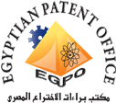
Mohammed Hisham, a 2016/2017 BUE graduate and a former researcher at FECSFS, was honored by the Minister of Higher Education and the President of the Academy of Scientific Research at the 4th International Innovation Exhibition. The essence idea for Mohammed’s graduation project has been deemed subject patenting by the Egyptian Patent Office following the received award at Cairo Innovates International Exhibition.
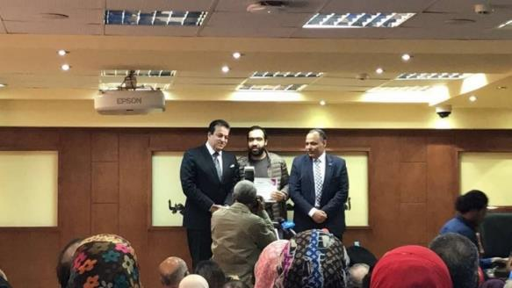
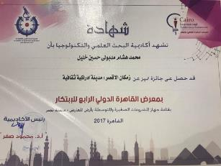 | 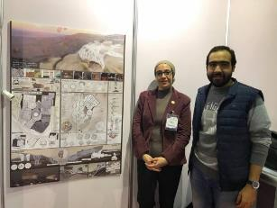

3. Graduation Project ideas associated with Civilization Rights to Build Civilization Research
Transforming the idea of Civilization Rights to Build Civilization Building to a graduation project for the students of the Faculty of Engineering, Zagazig University and the Modern Academy
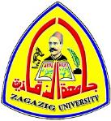  During a symposium held at Zagazig University, in the presence of Prof. Amr Farouk, Vice President of the Academy, the Civilization Rights building was put up to be a graduation project for a group of 8 students from the Faculty of Engineering. Professor Ahmed Rashed as a PI of the Civilization Rights project helped communicate the idea and support the program and follow the development of student’s projects. The project tackled the idea of designing a Civilization Rights Building (CRB). CRB was deemed to be like headquarters of the world’s civilization rights (most like the United Nations building) and the students were to design a building and how it can be central to play an important role in addressing the rights of ancient civilizations across the world, protecting intellectual property, and resorting the rights from those who gain commercially from the heritage of nations. On July 17, 2018, the number of eight graduation projects for students of the Faculty of Engineering, Zagazig University was discussed. This demonstrated the students' awareness of the importance of the issue, the importance of the role to be played by the proposed building, and the different visions drawn for this building by the students. | 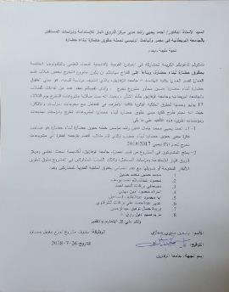  A statement signed from Zagazig University acknowledging that the rights and ideas used for the student’s graduation projects in 2018 are attributed to Professor Ahmed Rashed
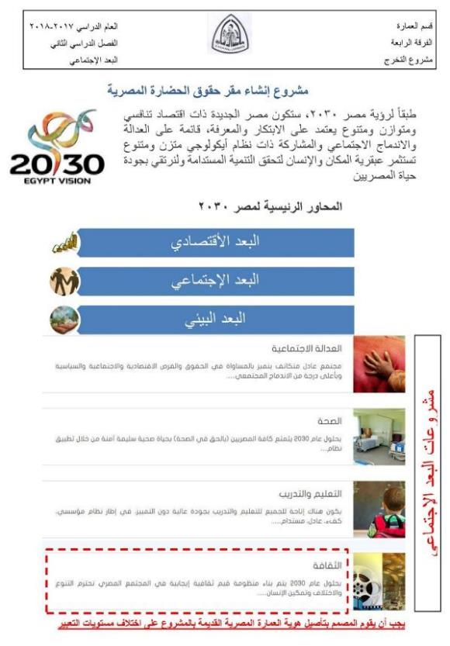
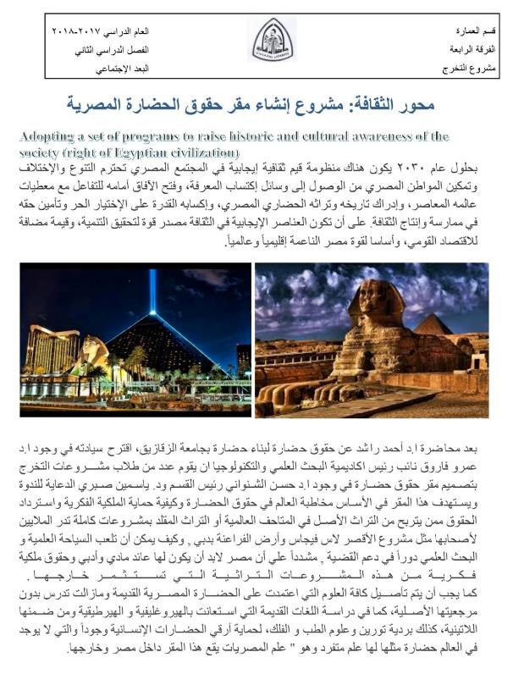
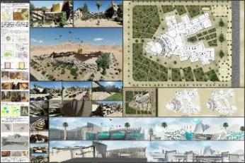 | 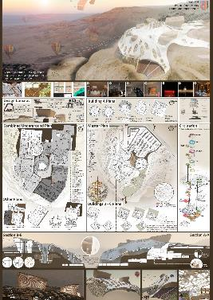
Osama Hashim’s Graduation project | Modern Academy - June 2018
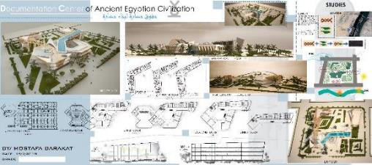 Graduates Projects of the Faculty of Engineering - Zagazig University" July 2018
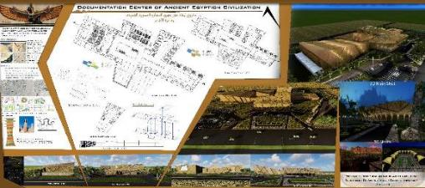
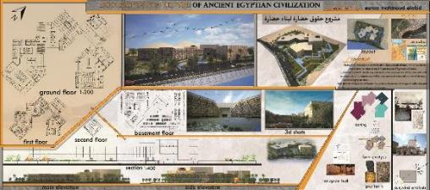
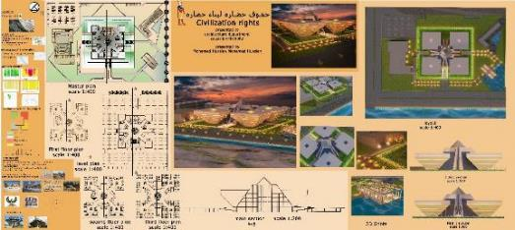
Graduates Projects of the Faculty of Engineering - Zagazig University" July 2018
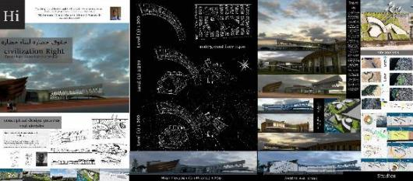
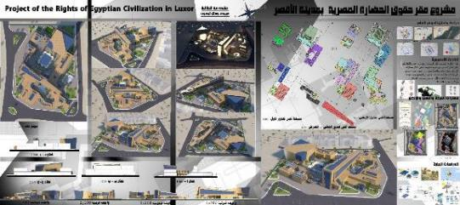

Graduates Projects of the Faculty of Engineering - Zagazig University" July 2018

4. Patentable Ideas Generated from the Civilization Rights to Build Civilization Competition
Over 50 ideas were presented to the competition from over 75 contestants. Each was assigned to a unique ID number and is deemed patentable. Below are some examples of the presented ideas and a list of all the ideas submitted to the Civilization Rights Competition.
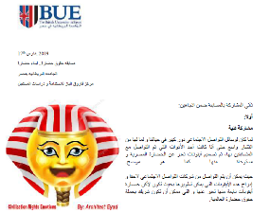 | 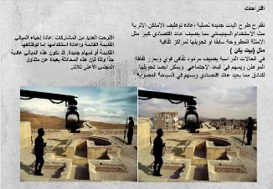
 | 
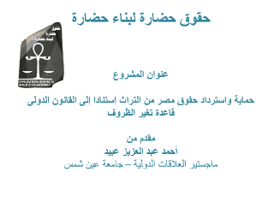 | 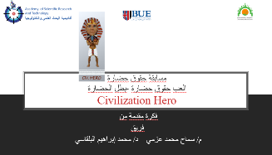
# | Main Participant | Idea Code | Idea Name
1 | Abdul Rahim Al Rayhan | CRC001 | - Intellectual Property Rights and Impacts in the Light of Organized Laws -Challenges, solutions and implementation mechanisms
2 | Abdul Rahman Othman | CRC002 | - My Museum In Your Classroom
3 | Abeer Tantawi | CRC003  CRC056 | - Civilization Rights Logo  - Employment of the Egyptian heritage displayed in museums of the world in marketing - Tourist destination of the Egyptian destination
4 | Ahmed Obaid | CRC004 | - Protecting and restoring Egypt's rights from archeology based on international law - Rule change conditions
5 | Ahmed Haroun | CRC005 | - A documentary about Civilization Rights in Cinema
6 | Alyaa Ali | CRC007 | - Logo & Poster about Nefertiti
7 | Amal Darbaki | CRC008  CRC009 | - Logo & Landmark  - Added Value of Egyptian Heritage
8 | Asma Alshahawy | CRC010 | - Short documentary film about the Shenwai Building
9 | Azza Mohammed | CRC011  CRC014 | - Report  - Report
10 | Ahmed Hassan | CRC012 | - The Lost Civilization Projects
11 | Aya El Meligy | CRC013 | - Reusing architectural heritage in order to build civilization
12 | Eyad Zamzam | CRC015 | - Emoji Design for Civilization Rights
13 | Ghada Kamar | CRC016 | - Mission of the people of - Mission of a homeland
14 | Hala Hassanein | CRC017 | - Guide to the world today in the field of ancient Egyptian civilization
15 | Heba Qutb | CRC018 | - Thousand Right & Right Report
16 | Heba Mahrous | CRC019 | - The role of cinematic art in the expression of ancient civilizations
17 | Hoda Anwar | CRC020 | - Logo & Report about Civilization Rights
18 | Khaled Dweidar | CRC021 | - Logo, Movie & Poster about the restoration of Demiana Monastery
19 | Lobna Mahmoud | CRC022 | - The return of the Civilization Rights as a support for the building of civilization in Western Sahara
20 | Magdy Malook | CRC023 | - Great Egypt Website
21 | Manar Hassan | CRC024 | - Souvenirs & Civilization Rights
22 | Mohammed al-Tahlawi | CRC025  CRC034 | - Civilization Rights Games  - Civilization Rights Cartoon
23 | Mohamed Mahmoud Abdel Rahim | CRC026 | - Protection of Antiquities and Egyptian Heritage - A vision between reality and the future
24 | Mohammed Abdul Razzaq | CRC027 | - Examples of Profiting of Egyptian Antiquities in Global Museums - Problems and Proposed Solutions
25 | Omar Muslimah | CRC028 | - Ancient Egyptians Heritage Manufacturing
26 | Mohammed al-Dabbousi / Mokhtar Aql | CRC029 | - Raising Awareness of Civilization Rights Through Community Participation in Heritage Sites Conservation
27 | Mohamed Belqasi | CRC030  CRC031  CRC032 | - Play Civilization Rights  - Inside First, those who waste their history will waste their present & future  - Creating a website and platform for Civilization Rights
28 | Mohammed Al Daboussi | CRC033 | - Civilization Rights Base for Organizations' Societal Marketing Plans
29 | Mohammed Khaled | CRC035 | - Civilization Rights Report
30 | Mokhtar Akl - Green | CRC037  CRC055 | - Contests as one of the methods of collective participation to stimulate the collective awareness of the claim the civilization rights to build civilization  - Architectural Heritage Competition
31 | Nira Galal | CRC038 | - Civilization Rights Competition Ideas
32 | Omnia Elsayed | CRC039 | - Civilization rights to build civilization, common approach - The lotus emission idea
33 | Radwa Ahmed | CRC040  CRC041 | - Identity Crisis - Research Paper  - Logo & 3 Posters
34 | Rami Dakrouri | CRC042 | - Civilization Rights Competition in Hieroglyphic
35 | Reda Atallah | CRC043 | - A proposed project for the contest of the civilization rights to build civilization
36 | Rania Kamal  Rola Kamal | CRC044  CRC045 | - Rania News  - Ambassador Nouran’s Cartoon
37 | Saeed Hassanein | CRC046 | - Holly Family Journey
38 | Yasmin Sabry | CRC047  CRC048  CRC049  CRC050  CRC051 | - Report  - Logo Design  - Civilization Rights Building Project (1)  - Civilization Rights Building Project (2)  - Civilization Rights Ideas – Sketches
39 | Amr Mostafa | CRC052 | - Amon App
40 | Rayam Baker | CRC053 | - Civilization Rights Logo
41 | Afaf Badran | CRC054 | - The Negative Museum

5. Patentable Ideas Generated from the Green Worship House Competition
As a result of the Green Worship House Competition (GWHC), the projects that were submitted to the competition were the first projects ever to use the Green Pyramid Rating System (GPRS) in Egypt, they will be submitted to be patents by the contests and the centre FECSFS is a partner with them as the first to implement the use of the GPRS. Total number of patents to be submitted are 19 patents.

# | Team Code | Team Leader | Project Name
1 | GWHC01 | Green – Mohamed Eldabosy | COM-UNIT Mosque
2 | GWHC02 | Green – Mokhtar Akl | Shade Worship Shelters
3 | GWHC03 | Nader Gharib | Light Journey
4 | GWHC05 | Sherif Fouad | Square Mosque
5 | GWHC06 | Hussieny Tohamy | Green Worship House
6 | GWHC07 | Randa Hassan | Sustainable Church Project
7 | GWHC08 | Randa Hassan | The Smart Sustainable Mosque in Elsherouk City
8 | GWHC09 | Randa Hassan | The Sustainable Masjid in El-Sherouk City
9 | GWHC10 | Walaa' AbdelFatah | Capital Heights – Green Worship House
10 | GWHC14 | Rola Kamal | Baiu’s Dream
11 | GWHC15 | Nancy Badawy | Green Pyramid – Islamic Center
12 | GWHC18 | Darin Refaat | Karkar Mosque
13 | GWHC19 | Youssef Mohamed | All Gods Land is a Mosque
14 | GWHC20 | Hala Raslan | Spirit of Worship
15 | GWHC21 | Mohamed Kamal | Worship House Project
16 | GWHC22 | Mohamed Ashraf | Green Worship House – Sahl El Tina Area
17 | GWHC23 | Randa Hassan | The Green Mosque
18 | GWHC24 | Samar Allam | Green Worship House
19 | GWHC25 | Mokhtar Akl | Rosetta Mosque

7. Technology Transfer
Since its inception, FECSFS has paid close attention to technology transfer and the process of disseminating generated ideas, technology, and tools to achieve broader community impacts. Technology transfer has been central to all the conferences and workshops organized by FECSFS. Furthermore, we have signed several MOUs and entered collaboration agreements to move our ideas into practice by organizations and communities. During the past year FECSFS has initiated three exemplary efforts of technology transfer:
- Organizing the third International Conference on Architecture and Urban Design (ICAUD), to be held on 24 – 26 October, 2019 in Tirana, Albania. With the following partners GDANSK UNIVERSITY OF TECHNOLOGY, POLITECNICO DI BARI, "MOTHER TERESA", UNIVERSITY, UNIVERSITY OF TETOVA, FEDERICO ll UNIVERSITY OF NAPLES, THE BRITISH UNIVERSITY IN EGYPT, UNIVERSITA DEGLI STUDI DI PALERMO, INSTITUTI I MONUMENTEVE TE KULTURES “GANI STRAZIMIRI”, HELWAN UNIVERSITY, UTRECT UNIVERSITY OF APPLIED SCIENCES, UNIVERSITY OF CAMPANIA "LUIGI VANVITELLI". http://icaud.epoka.edu.al/2019/category-welcome-to-3-icaud-2436.html
- Organizing summer school Title” SpaRe.life 2019-PG | Pocket Gardens. Ephemeral Regeneration of super-blocks in Tirana http://sparelife.epoka.edu.al/2019/
- Starting close collaboration with American Society of Heating, Refrigerating and Air-Conditioning Engineers (ASHRAE) through its Egyptian’s Chapter to further develop the ideas and recommendations that were delivered from the Green Heritage Conference organized by FECSFS in 2018.
- Organized a conference with the National Center for Housing and Constructions Research on Aswan with the title of “Sustainable Construction and Project Management – Sustainable Infrastructure and Transportation for Future Cities”
- Collaborating with the National Center for Housing and Constructions Research to develop the Egyptian version of the green rating system, following recommendations and ideas generated from the Green Worship House Competition
- Encouraging graduating students all over Egyptian Universities to pursue their graduation projects based on topics related to the projects and conferences conducted by FECFS.

In the next few pages we cover information related to each of the above-listed efforts.

- The Conference
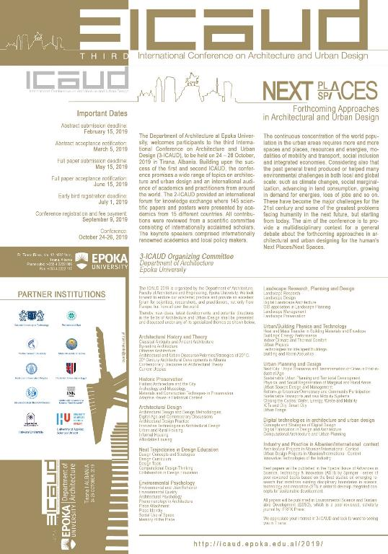

- The Summer School
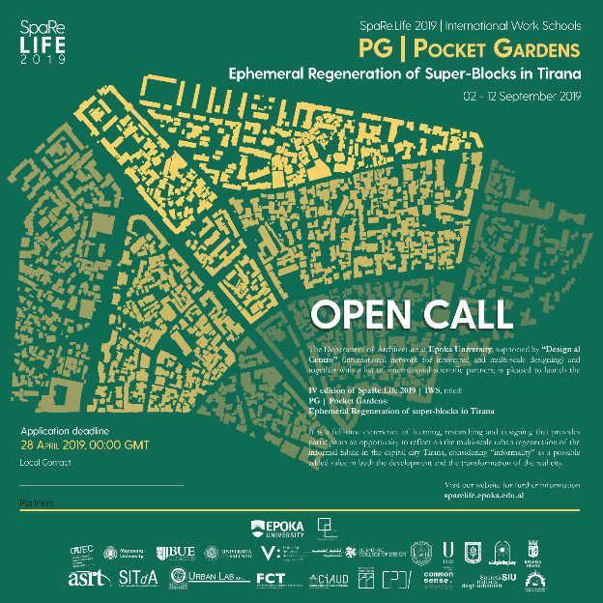

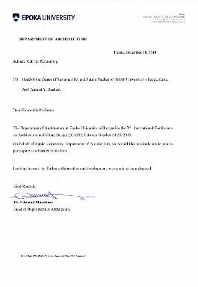
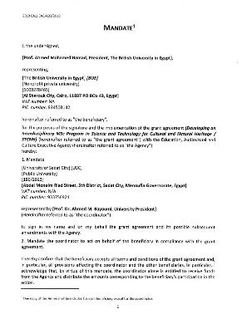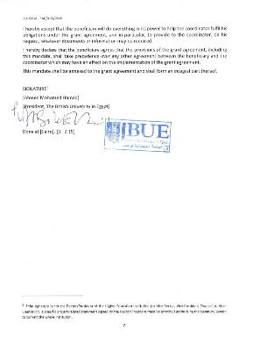

3. Collaboration with ASHRAE
Efforts associated with Dr. Hesham Safwat Activities and are related to EFCSFS
- Award winning competition for air-conditioning bed project year 4 mechanical 2019 in ASHRAE HVAC competition 2018-2019 for universities
- ASHRAE – BUE - seminar in British university hall with the collaboration with FECSFS and announcement for ASHRAE society for the civilization rights competition
- ASHRAE word society interview for Dr Farouk Elbaz and the role of sustainability in new societies with his historian life interview
- ASHRAE director region Dr Ahmed Alaa meeting with Dr Farouk for future potential cooperation with FECSFS and capability of doing MOU agreement
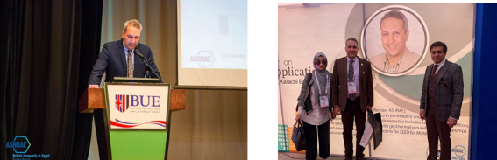
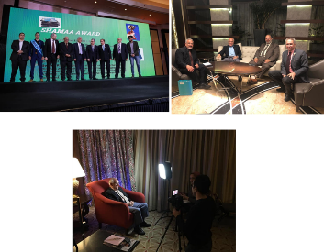 | 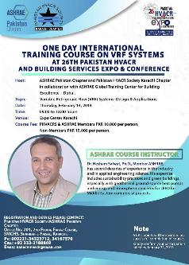

- Sustainable Construction and Project Management – Sustainable Infrastructure and Transportation for Future Cities Conference
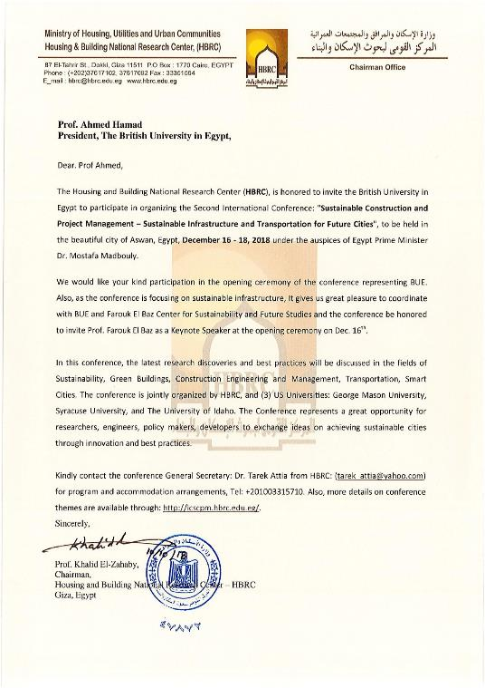

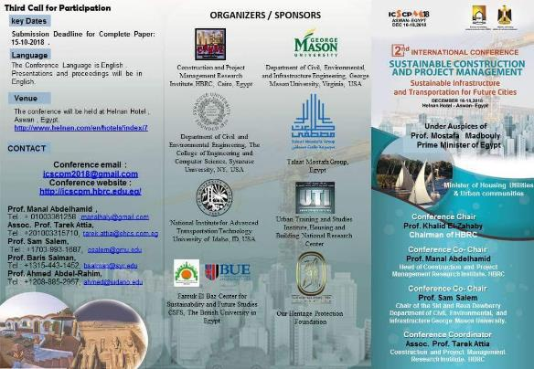
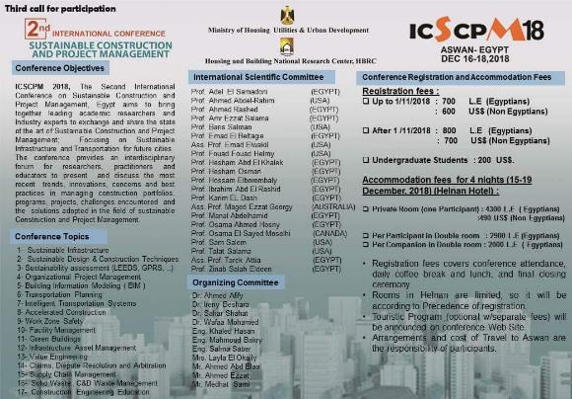

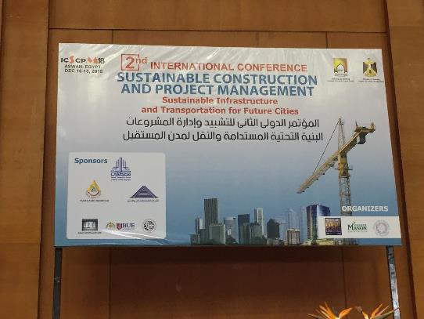
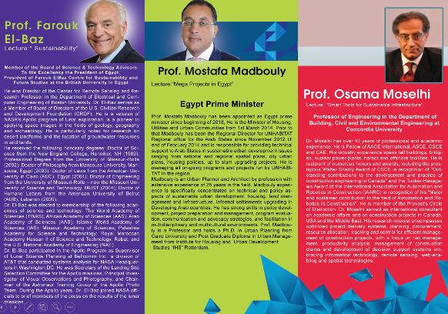
5. Egyptian Green Rating System
Efforts conducted in collaboration with the National Center for Housing and Construction Research under the leadership of Dr. Khaled Al-Zahaby
In 2010, National Center for Housing and Construction Research developed Egypt’s first national green rating system known as the Green Pyramids in conjunction with the Egyptian Green Building Council. The Green Pyramids represents the contextual adaptation of several international rating systems. It aims at assessing sustainable building performance based on sustainability of site selection, water and energy efficiency, materials selection and construction system, indoor environmental quality, innovation and design and recycling of solid waste. Four certification levels are granted according to the total scoring points of buildings and how much they satisfied all sustainable requirements. These are arranged from the least to the highest level as follows; certified, silver, golden and green certification level.

In 2017, FECSFS organized in collaboration with the National Center for Housing and Construction Research a competition that aimed at designing a green worship house that complies with all sustainable criteria explained in the Green Pyramid rating system. The selection or worship housing came as a pilot project for expanding the application of the green pyramid rating system in other building types and scales. Hence, applicants were required to investigate the assessment criteria stated by Green Pyramids rating system and apply it in their design projects.

On Wednesday, 02 May 2018, the results of the Green Worship House Competition (GWHC) were announced in an event organized by FECSFS. The event was attended by 19 teams and most of the juries and the National Center for Housing and Construction staff. Attendees included. Prof. Khalid Al-Zahabi, Head of the Center, Omaima Ahmed Salah El-din, former head of the Center, Prof. Ahmed Yahia Rashed, the Director FECSFS., and Dr. Saad Makram, the architecture teacher at Mansoura University, and one of the judges and sponsors in the competition.
FECSFS is in the process now to consolidate lesson learned, refining recommendations, and charting a roadmap for the National Center for Housing and Construction on extending the Green Pyramid rating system to other buildings and for broader applicability across Egypt.
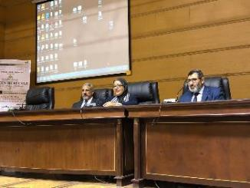 | 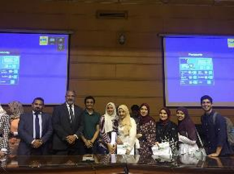
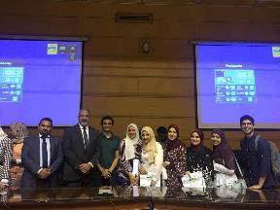 | 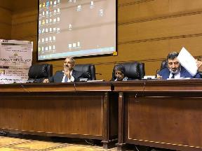
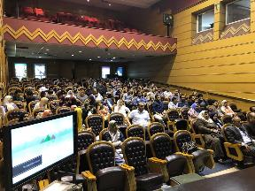 | 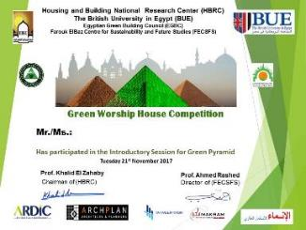
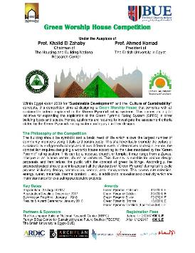 | 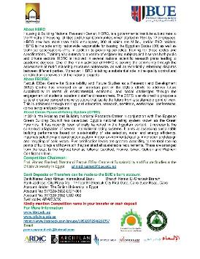
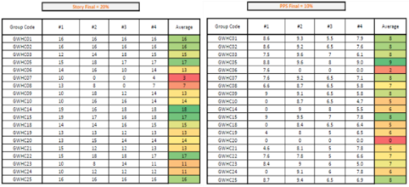
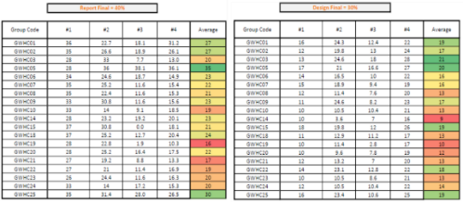
6. Encouraging graduating students all over Egyptian Universities to pursue their graduation projects based on topics related to the projects and conferences conducted by FECFS
Examples
Engineering Graduation projects are the final stage for academia and the start stage of real life. It reflects an investment of ideas and future options for Egypt to achieve the challenges of sustainable development. GPD at BUE is an annual event that facilitates the opportunity for the best future engineers to present and fully explain their projects to the elite members of engineering community from all over Egypt.
Inspired by the Egypt’s vision 2030 and the challenges of developing sustainability, FECFS has promoted many ideas and scenarios of different engineering disciplines to be presented during the GPD at BUE. The event created a dialogue between ideas and real needs of market and industry. All the engineering departments are working under one important theme which is the green infrastructure.
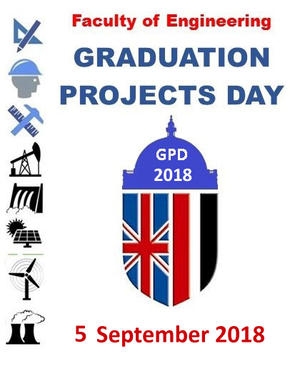 | 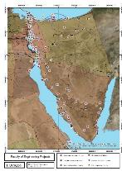
 | 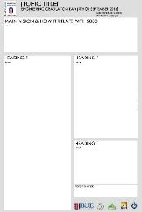
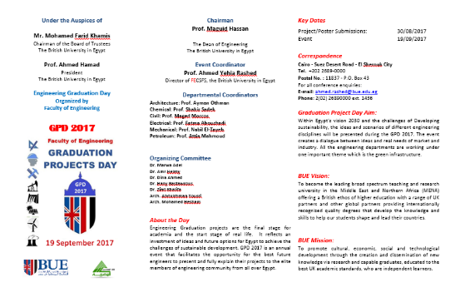
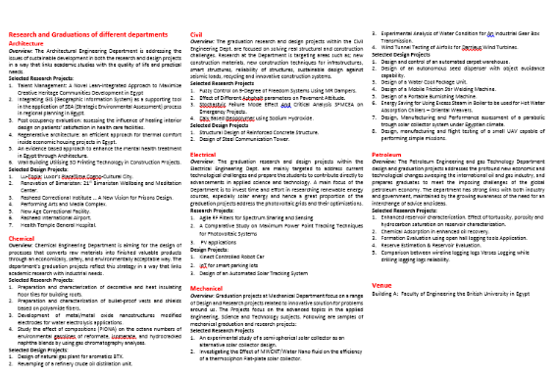

8. Community Engagement
Most of the projects carried out by FECSFS are of large, national scales. Therefore, FECSFS pays strong attention to community engagement to ensure the inclusion of members from all sectors of the communities: research, government, academics, industrial, in addition to people from the public. We also seek to engage with people at various stages of their lives and their careers: the youth and the elderly, students and professionals, those in the early stage in their career, and those with established careers. Community engagement is the subject of Professor Ahmed Rashed’s doctoral research that looked at public participation in the conservation of the Luxor’s heritage. It continues to be the philosophy dominating FECSFS mission. We take every effort to identify the stakeholders of all our projects and work collaboratively with them to address the challenges in questions. We also use community engagement as an effective means to enhance the knowledge and skills of the stakeholders on the subject matters, and hence their possible contributions to research and challenges we tackle.
The period between May 2018 and 2019 was full of diverse community engagement and partnership building that were conducted by FECSFS to engage people from across all sectors in Egypt in the Civilization Rights to Build Civilization Campaigns. The activities included (but were not limited to) the following:
- Organizing educational and awareness seminars across universities, professional organizations, research center, and civic associations to introduce topics and concepts related to Civilization Rights.
- Conducting interviews with different types of media: newspapers, magazines, social publishers, TV, and radio channels to explain the nature of the campaign and answer questions.
- Participating in exhibits and professional meetings to introduce the case of Civilization Rights.
- Developing and distributing different types of materials including flyers, video briefings, and social media live broadcasts to inform the public about Civilization Rights.
- Organize and announcing a national competition open to every Egyptian to solicit ideas and contributions.
- Conducting a workshop to discussed proposed ideas, provide feedback to contributors, and encourage further development of the proposals.
The sections below provide a glimpse into some of these activities across each of the above-listed areas.

1. Awareness Seminars
For the Civilization Rights to Build Civilization Campaign
FECSFS team members conducted tours across Egypt and organized seminars to address over 3500 university professors, researchers, students, experts and specialists, and introduce them to the goals and objectives of the campaign and encourage them to participate and contribute. Below is a partial list of the events that were held:
- Beni Swief University
- Fioum University
- Menya University
- Assiut University
- Sohag University
- South Valley University (Luxor)
- Luxor Public Library
- Aswan University
- Egyptian Innovation Bank
- Sinnary House
- Nile Academy, Mansoura
- Zagazig University
- Farous University (Alexandria)
- Higher Institute for Engineering (Al-Abour, Cairo)
- TED X BUE
- Kafr Al-Shiekh University
- Masr University for Science and Technology
- TED X Zagazig University
- Effat University (Saudi Arabia)
- Saudi Authority for Tourism and Heritage (Saudi Arabia)
- Culture Heritage Cluster Conference (DAAD Institute, Cairo)
- Nubia Club (Cairo)
- “Together for Egypt” conference held at Ain Shams University
- "مؤسسة نحمي تراثنا" in Aswan
- Symposium on resilient cities: urban resilience and regeneration held in Giza
- Symposium on environmental tourism, Cairo
- Engineers Syndicate in Dakhalia
- The Arab Conference on Astronomy and Geophysics
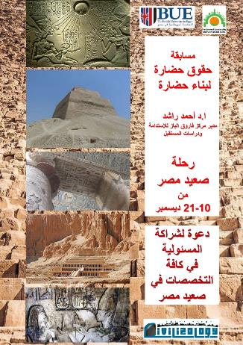 | 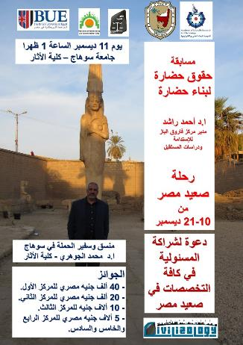
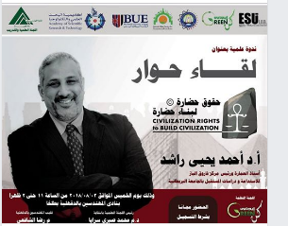 |  |  | 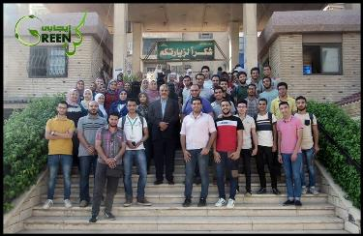
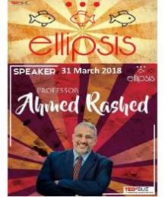
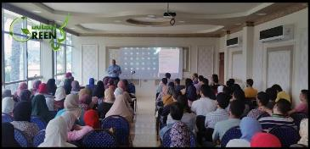

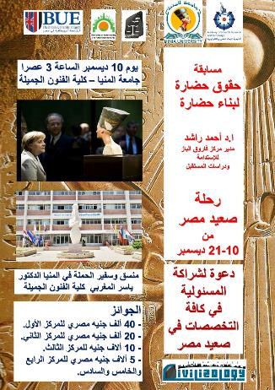 |  | 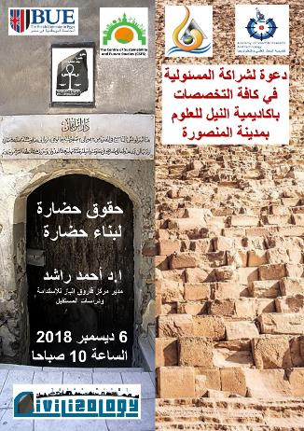
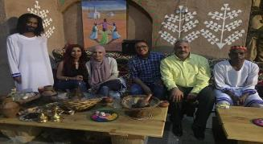 |  |  | 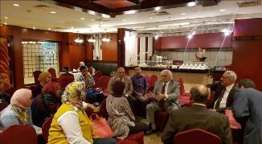
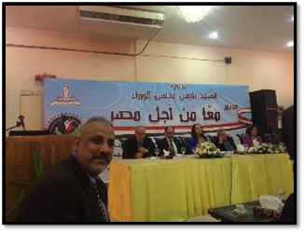 |  |  | 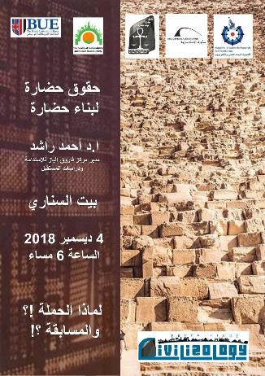
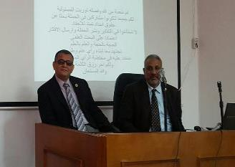
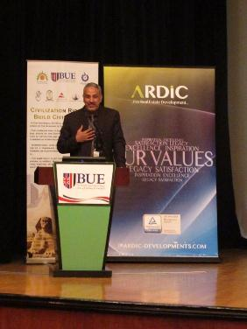 |  |  | 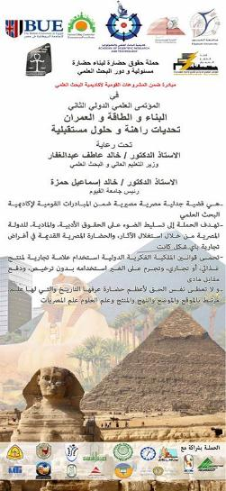
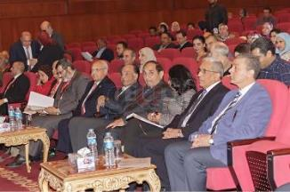 |  |  | 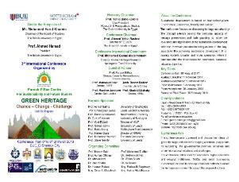
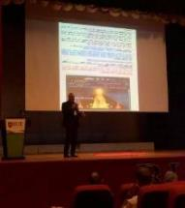
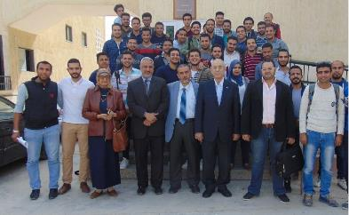
 |  |  | 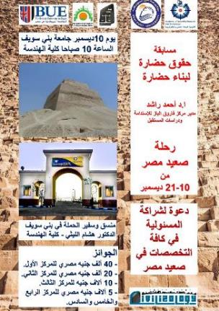
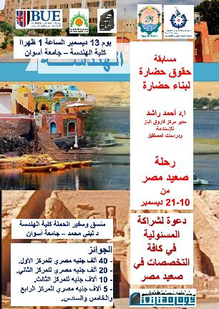

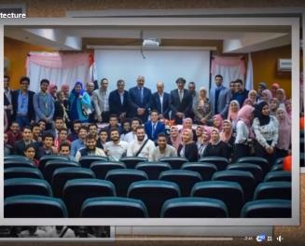 |  |  | 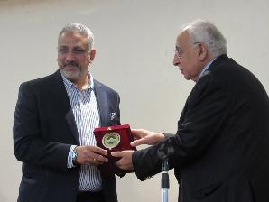
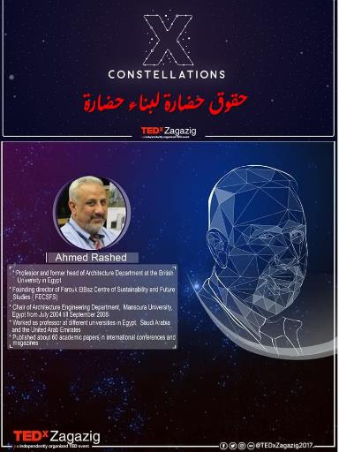 |  |  | 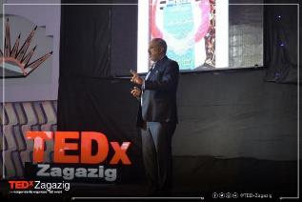
 |  |  | 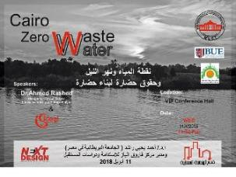
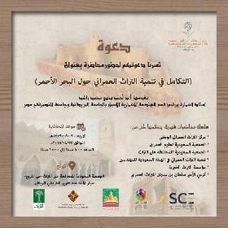 |  |  | 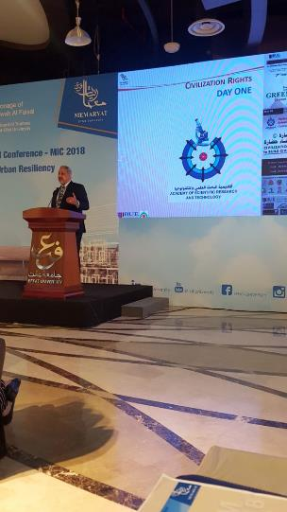
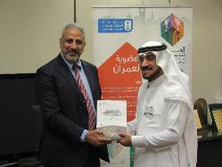
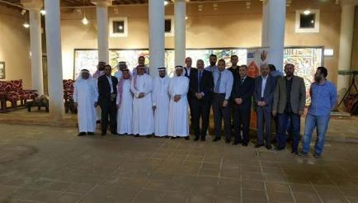
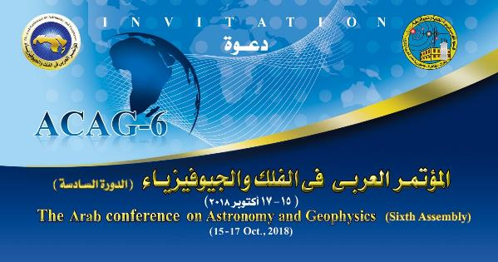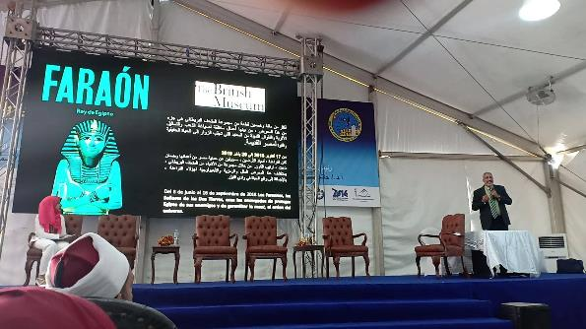
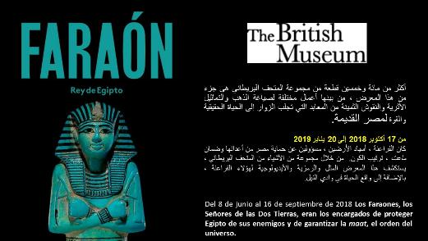
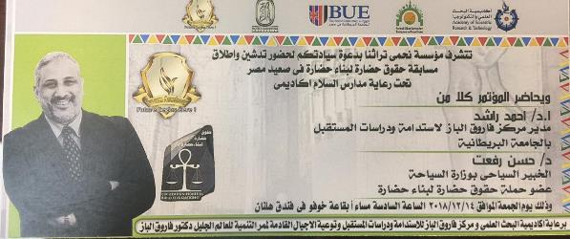
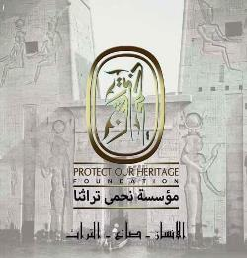
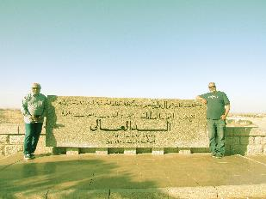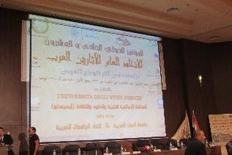
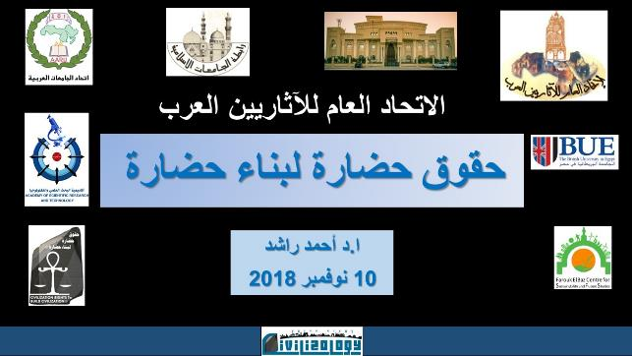

2. Media Interviews
Various Projects
The director of FCSFS has been frequently interviewed and/or hosted in news outlets including newspaper, professional magazines, and TV and Radio shows to discuss the different initiatives and project in which FECSFS has been involved. Below is a partial list of such interviews and talks since 2011
Dec 27, 2011 | “Women Can’t Lie” show, CBC TV https://www.dailymotion.com/video/x5s424d
Apr 12, 2012 | Al-Bashayer News Paper
Dec 1, 2012 | Elnabaa Newspaper
Feb 16, 2014 | Al-Dostor Newspaper
Dec 26, 2014 | “News Report,” Syria Satellite Channel, https://www.youtube.com/watch?v=iqe0Tl_bxPs
Jun 10, 2015 | Al_Bawaba News Portal
April 18, 2015 | “Egypt Tomorrow!” show, Nile Culture TV https://www.youtube.com/watch?v=QCf2r_9FiT4
May, 2015 | “Sawa”, Radio Interview https://www.youtube.com/watch?v=U9YkeZGisf0
May 3, 2015 | “TV Interview”, Al-Manarh TV https://www.youtube.com/watch?v=HhLGJ0LNexs
July 30, 2015 | Watani Newspaper
Aug 5, 2015 | Al-Fagar Newspaper
Aug 8, 2015 | “In Love of Egypt” show, Channel 1, Egyptian TV https://www.youtube.com/watch?v=zdYd15f2rfM
Aug 8, 2015 | “New Page” show, Nile TV https://www.youtube.com/watch?v=TI8-BngPBcc
Aug 9, 2015 | “Dream’s Morning” show, Dream TV https://www.youtube.com/watch?v=2HOk60rEVaw
Oct 5, 2015 | “Disciplined!” show, Nile Culture TV https://www.youtube.com/watch?v=zoJ_-RaHrYg
ـJun 28, 2016 | “People from our Country” show, Sada El-Balad TV https://www.youtube.com/watch?v=w8IhH6W0Fic
ـJun 28, 2016 | “Breakfast Show” show, Nile TV https://www.youtube.com/watch?v=Supi1MmKDiw
ـJun 28, 2016 | “Breakfast Show” show, Nile TV https://www.youtube.com/watch?v=Supi1MmKDiw
Nov 11, 2016 | “People of Egypt” show, Nile Culture TV https://www.youtube.com/watch?v=hitt-fcpi1Y
July 16, 2016 | Dot MSR News Portal
Sep 23, 2017 | “Money Means Business” show, Nile TV https://www.youtube.com/watch?v=RxlQIm6h_4w
Jan 7, 2018 | Al-Ahram Newspaper
Nov 2, 2017 | Arab Tourism Portal News
Jan 7, 2018 | Egypt News Portal
Jan 7, 2018 | Al-Isbou Newspaper
Jan 9, 2018 | “Egyptian Tale” show, Nile Culture TV https://www.youtube.com/watch?v=VMidlIB-VvE
Jan 9, 2018 | “Beautiful Egypt” show, Channel 2, Egyptian TV https://www.youtube.com/watch?v=_rv_V8Up2Jw
Jan 17, 2018 | “Cairo Morning” show, Cairo TV https://www.youtube.com/watch?v=IbSlR6yo_Qk
Jan 21, 2018 | “Daily Debate” show, Nile TV https://www.youtube.com/watch?v=yTLSjN0-Evg
Feb 2, 2018 | Veto Gate News Portal
Feb 2, 2018 | “Science of Our Lives”, Radio Show https://www.youtube.com/watch?v=uuqUO6nC_-A
Feb 6, 2018 | Day 7 Newspaper
Feb 6, 2018 | El-Watan Newspaper
Mar 2, 2018 | “New Day”, Nile Culture TV https://www.youtube.com/watch?v=8KhtgD2MVEA
Mar 6, 2018 | Veto Gate News Portal
Mar 6, 2018 | Masress News Portal
Apr 20, 2018 | Al-Balad Daily Newspaper (Saudi Arabia)
Apr 23, 2018 | Laha Magazine (Saudi Arabia)
Apr 30, 2018 | Al Madina Newspaper (Saudi Arabia)
Apr 27, 2018 | Media Portal of the Saudi Commission for Tourism and National Heritage (Saudi Arabia)
Apr 30, 2018 | Baraq News Portal (Saudi Arabia)
May 4, 2018 | Rania News Portal
Jul 2, 2018 | Al-Shabab Magazine

3. Exhibits, one-to-one professional meetings
Civilization Rights to Build Civilization Campaign
The FECSFS team has been reaching out to a large number of university professors, experts, and activists, and specialists via different means including one-to-one visits, professional meetings, and e-mails to solicit their opinion regarding the acceptance to participate in the Civilization Rights Competition as judges of the submissions that the competition is expected receive, as well as the formation of what is known as the Civilization Rights to Build Civilization alliance. The contacted personnel covered different backgrounds (legal - tourism - archaeological - economic - media ...) and a lot of them were already aware of the campaign and participated in the various stages. The following are sample materials of the emails that were distributed to the experts, as well as the MOUs and/or agreement draft signed with them.
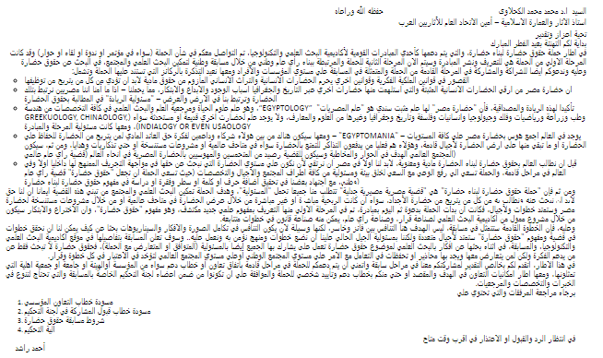
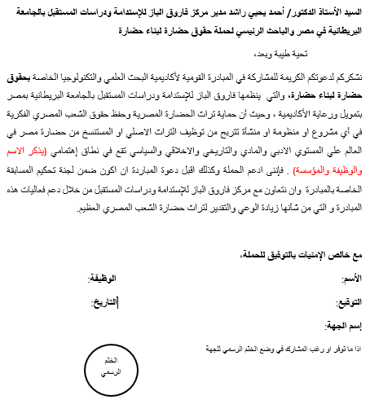
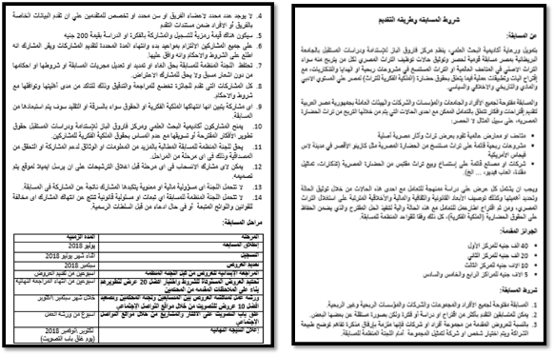
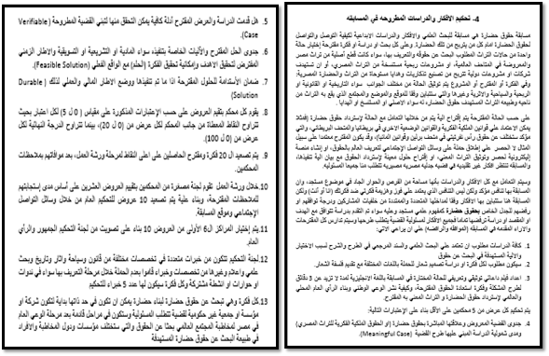

The Civilization Rights to build Civilization Campaign is in partnership with:
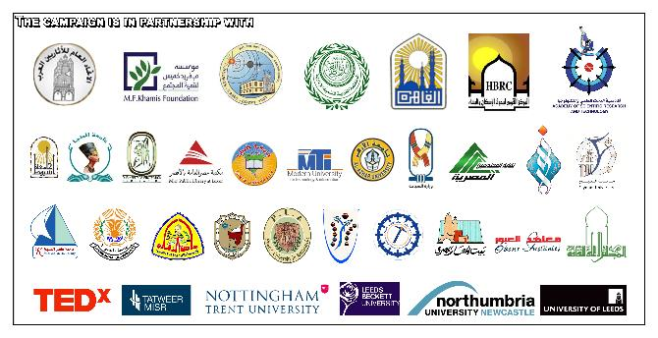

Also, the following pictures are the IDs for the Advisors, Ambassadors and member for the Civilization Rights to Build Civilization Campaign:

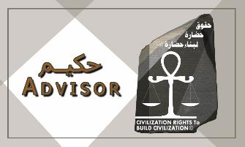 | 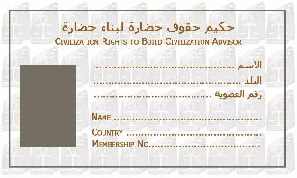
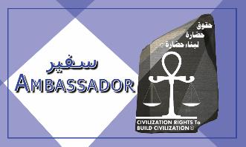 | 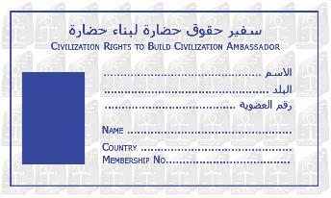
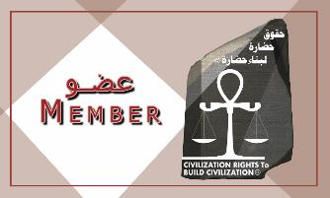 | 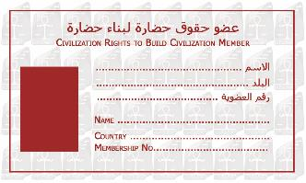

The following is a list of experts who has joined the jury committee of the Civilization Rights campaign
الاستاذ الدكتور ايمن ابو حديد: استاذ متفرغ – قسم البساتين, كلية الزراعه , جامعة عين شمس.، وزير الزراعة و استصلاح الأراضى الأسبق، رئيس مركز البحوث الزراعية الأسبق، الرئيس السابق لجهاز شئون البيئة،حاصل علي وسام العلوم و الفنون من الطبقة الاولي، وحاصل علي جائزة الدولة التقديرية في العلوم الزراعية | 
الاستاذ الدكتور محمد يوسف: وزير التعليم الفني والتدريب السابق، عضو مجلس إدارة شركة المقاولون العرب، حاصل علي الماجستير و الدكتوراه من المملكه المتحده، عمل بشركة المقاولون العرب (عثمان أحمد عثمان و شركاة) منذ تخرجه في العديد من المشروعات الكبري ثم اصبح مسئولاً عن التدريب المهني و مدارس التعليم الفني بالشركة، عيُن نائباً لوزير التربيه و التعليم للتعليم الفني | 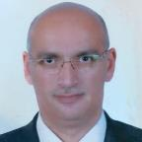
الاستاذ الدكتور صالح الهذلول: وكيل وزارة الشؤون البلدية والقروية لتخطيط المدن بالمملكة السعوةدية من 1984\2004، استاذ وناقد معماري بجامعة الملك سعود، خبير ومحكم دولي في العديد من المسابقات والمؤتمرات الوطنية والاقليمية والدولية، وله العديد من المؤلفات في ِان المجتمعات والعمران والدراسات المستقبلية (المملكة العربية السعودية) | 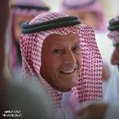
لمهندس ابراهيم حرك: خبير استثمار في وزارة الاستثمار والتعاون الدولي ومستشار الاستثمار للهيئة الاقتصادية لقناة السويس ماجستير ادارة المشروعات من جامعة القاهرة وماجستير ادارة الاستثمار من الأكاديمية العربية للعلوم والتكنولوجيا، عضوية مجلس ادارة الشركة القومية للاسمنت وشركة الصعيد البحر الأحمر للاستثمار | 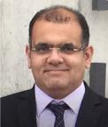
الاستاذ الدكتور أحمد الحفناوى: عضو هيئة تدريس في قسم الهندسة الحيوية الطبية والمنظومات بهندسة القاهرة، رئيس مجلس أمناء مؤسسة المعرفة للجميع، سابقا عمل مستشار رئيس الجهاز القومي لتنظيم الاتصالات، ونائب رئيس الهيئة القومية للبريد للتخطيط الاستراتيجي وتكنولوجيا المعلومات والعلاقات الدولية، مستشار وزير الصناعة والتنمية التكنولوجية، مدير تنفيذي برنامج التنمية التكنولوجية في مركز المعلومات ودعم اتخاذ القرار | 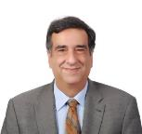
الكاتب الصحفى الاستاذ أحمد السرساوى: نائب رئيس تحرير جريدة أخبار اليوم، متخصص فى الشئون السياسية والاستراتيجية، زميل أكاديمية ناصر العسكرية العليا، باحث دكتوراة فى الاعلام والعلاقات الدولية، مستشار اعلامى سابق لوزارة التضامن المصرية، منتج وسيناريست أفلام وثائقية، زار نحو 40 دولة، وله أربع كتب فى السياسة والسير الذاتية والرحلات والابداع القصصى | 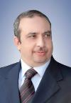
الأستاذ الدكتور أحمد حمزة، رئيس جامعة المنصورة الأسبق ورئيس الجامعة البريطانية فى مصر السابق، زميل المعهد البريطانى للفيزياء بلندن وزميل الجمعية الملكية للميكروسكوب بأوكسفورد وعضو الجمعية الدولية للبصريات بواشنطن، له أكثر من 150 بحثا منشورة دوليا، حصل على نوط الامتياز من الطبقة الأولى وجائزة الدولة التقديرية، والدكتوراه الفخرية من الجامعة التكنولوجية بليبريتس، جمهورية التشيك. وجائزة النيل فى العلوم التكنولوجية المتقدمة. | 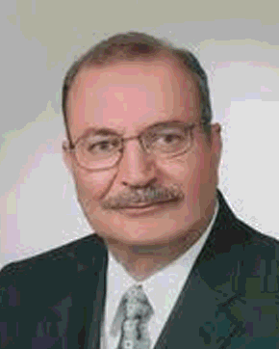
الاستاذ الدكتور احمد عبد الرحيم: استاذ هندسة الطرق و المرور بجامعة ايداهو بامريكا و مدير معهد دراسات النقل المتقدمة بالجامعة، له العديد من الابحاث فى مجال انظمة النقل المستدامة، انظمة النقل المتقدمة، المدن المستقبلية، تخطيط شبكات النقل، و انظمة الامان على الطرق. د. احمد عبد الرحيم له اكثر من 96 بحث منشور فى المجلات العلمية و المؤتمرات الدولية. | 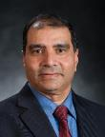
احمد عبده جعيص: رئيس جامعة أسيوط الاسبق، استاذ الكيماء العضوية بكلية العلوم، له كثير من الدراسات والأبحاث المتميزة، وذلك فى مجال تحضير المركبات الخلقية غير المتجانسة، وكيل كلية العلوم لشئون الدراسات العليا والبحوث ثم نائب رئيس الجامعة لشئون خدمة المجتمع وتنمية البيئة، ثم نائباً لرئيس الجامعة لشئون الدراسات والبحوث، كذلك عمل نايبا لشئون قطاع التعليم والطلاب | 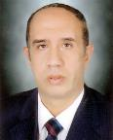
الاستاذ الدكتور اسلام الغنيمي: استاذ العمارة بجامعة البحرين وكلية الفنون الجميلة بالاسكندرية له العديد من الكتب والابحاث المنشورة وخبرات استشارية في مشروعات الاستدامة والحفاظ علي التراث بالدول العربية والاقليمية مثل كردستان و لبنان والامارات والسعودية كما انه عضو في العديد من جمعيات والمنظمات المعمارية الدولية (البحرين) | 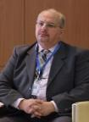
المهندس اشرف مشهور: مستشار وزارة التنمية الادارية السابق، خبير هندسة الإلكترونيات والاتصالات الكهربائية، له 3 براءات اختراع في ذلك المجال، و وله 19 عاماً في شركة IBM ومنها قام بمهام مدير عام الخدمات الشئون الفنية والهندسية على مستوى الدولة المصرية بالكامل، خبير بوزارة الاتصالات وتكنولوجيا المعلومات، آخر عامين منها رئيساً لقطاع تنمية الاستعداد الرقمي. | 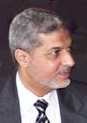
الاستاذ الدكتور أماني مسعود الجديني: استاذ العلوم السياسية بجامعة القاهرة والجامعة البريطانية في مصر، عملت كمحاضر فى جامعات نبراسكا ويزليان وواينونا بمينسواتا بالولايات المتحدة الامريكية فى العام الاكاديمى 2004- 2005ولقد شغلت منصب مدير مركز دراسات الدول النامية بكلية الاقتصاد والعلوم السياسية جامعة القاهرة ومستشار لكثير من الهيئات الاكاديمية والمنظمات الدولية | 
الاستاذ الدكتور إيمان جاد: عميد كلية التربية بالجامعة البريطانية في دبي، استاذ التربية الخاصة والدامجة الشرفي بجامعة جلاسكو الاسكتلندية ورئيس برنامج الدكتوراة بالجامعة، استشاري أول لدي اليونسكو لئون الاعاقة والدمج الاجتماعي، فازت بعدة جوائز منها منها جائزة الاميرة هيا وجائزة الادارة الجامعية الدولية واختيرت كواحدة من افضل 50 إمرأة مؤثرة في الادارة الجامعية من قبل الكونجرس الدولي التربوي | 
الاستاذ الدكتور ايمان عيد : وكيل الدراسات العليا والبحوث بكلية الهندسة جامعة المنوفية، ورئيس قسم الهندسة المعمارية- كلية الهندسة-جامعة المنوفية، أستاذ العمارة - تاريخ ونظريات العمارة، ورئيسة نادي روتاري حورس | 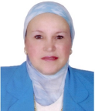
استاذ أيمن ابوزيد دبلومة سياحة وفنادق جامعة الاسكندرية: مستشار سياحى لشركة العجمى للسياحة بالاقصر، عضو نقابة المرشدين السياحيين، رئيس الجمعية المصرية للتنمية السياحية والاثرية بالاقصر | 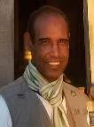
الاستاذ الدكتورجاد القاضى: استاذ الجيوفيزياء التطبيقية، نائب رئيس المعهد للعلاقات العلمية والثقافية، ومنسق العلاقات الدولية المعهد القومى للبحوث الفلكية والجيوفيزيقية، حاصل على دكتوراه من جامعة كيوشو (اليابان)، ‎عمل فى وظيفة القائم باعمال رئيس المعهد القومى لعلوم البحاروالمصايد، ومدير العلاقات الدولية بالجامعة المصرية اليابانية- برج العرب، كما عمل الملحق الثقافى والعلمى والتعليمى لمصر فى اليابان- و كوريا الجنوبية | 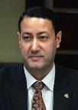
الاستاذ الدكتور جلال عثمان: أستاذ نظم الطاقة المتجددة، في جامعة المنصورة. رئيس جمعية طاقة الرياح منذ عام 1986حتى الحاضر. الرئيس ونائب رئيس جمعية طاقة الرياح العالمية منذ عام 2002 حتى الآن. حاضر وحضر كافة المؤتمرات الدولية المرتبطة بجمعية طاقة الرياح العالمية . | 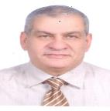
الدكتورة جيهان سليم: تعمل حاليا بجامعة ليدز بالمملكة المتحدة، زميلة في معهد السيناتور جورج ميتشل للسلام العالمي والأمن والعدالة. حصلت على درجة الدكتوراه من جامعة شيفيلد، وعملت في العديد من مدارس الهندسة المعمارية في شيفيلد وجامعة كوينز بلفاست في المملكة المتحدة، والإمارات العربية المتحدة. | 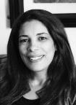
الاستاذ الدكتور حاتم عودة، رئيسا للمعهد القومي للبحوث الفلكية والجيوفيزيقية، أستاذ الجيوفيزياء التطبيقية، حصل على درجة الدكتوراه من جامعة ميونيخ، ألمانيا. وقام بعمل بحوث ودراسات في قسم علوم الأرض والكواكب، جامعة طوكيو، وعمل في قسم الآثار، جامعة الملك سعود، عضوا في مجلس إدارة العديد من المنظمات المحترمة مثل الجمعية الجيوفيزيائية الألمانية، وجمعية الصخور المغناطيسية اليابانية، | 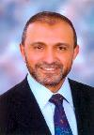
الاستاذ الدكتور حسام اسماعيل: استاذ الآثار الإسلامية، كبير مفتشين آثار إسلامية وقبطية 1982. مفتش آثار إسلامية وقبطية 1977 بمركز تسجيل الآثار الإسلامية والقبطية بمركز تسجيل الآثار. هيئة الآثار المصرية. عدة مؤلفات في المعهد الفرنسي للآثار الشرقية والجامعة الأمريكية وهيئة الكتاب المصرية | 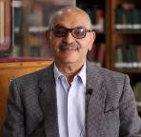
الأستاذ الدكتور حسام الدين البرمبلى مهندس استشاري و أستاذ العمارة بكلية الهندسة جامعة عين شمس، ورئيس القسم الاسبق، حاصل على الجائزة العربية لمهندس الصيانة المتميز لعام 2017، له العديد من المشروعات المعمارية في مصر والعالم العربي والاشراف علي المتاحف التراثية، عضو اللجنة الدائمة للآثار الإسلامية والقبطية بالمجلس الأعلي للآثار ، وخبير بالمعهد العربى للتشغيل والصيانة منذ 8 سنوات حتى الأن | 
الاستاذ الدكتور حسام الصغير: أستاذ القانون التجارى، ومدير المعهد الاقليمى للملكية الفكرية ووكيل كليه الحقوق جامعه حلوان (سابقا)، و الأستاذ الزائر بكليه الحقوق جامعه سانت لويس، و كليه الحقوق جامعه بيس نيويورك) والخبير لدى المنظمه العالمية للملكية الفكرية (الويبو) وعضو مجلس اداره الهيئه القومية لضمان جوده التعليم و الاعتماد، والمحامى بالنقض و الإدارية العليا." | 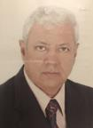
الدكتور حسام الوعر: مخطط واستاذ العمارة جامعة داندي بالمملكة المتحدة، ودراساته تتذكر في الاستدامة وشراكة المجتمع، حاصل علي جائزة لتأليف وتصميم المكان بالمشاركة وله العديد من المؤلفات والدراسات في ذلك الشان، استاذ زائر ومتحدث رئيسي في العديد من المؤتمرات الدولية وشارك في ورشة عمل حقوق حضارة بمؤتمر التراث الاخضر في مارس 2018 (المملكة المتحدة وسوريا) | 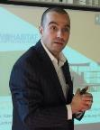
الاستاذ الدكتور حسام لطفي: استاذ القانون المدني، كلية حقوق بني سويف ورئيس القسم سابقا، استاذ كرسي اليونسكو لحق المؤلف والحقوق المجاورة، محام لدى محكمة النقض، خبير معتمد من المنظمات الدولية "ويبو" و " يونسكو" و" أليكسو" في مجال الملكية الفكرية، محكم معتمد من منظمة " وببو" في المنازعات المتعلقة بملكية أسماء الدومين والمواقع الالكترونية | 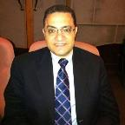
دكتور مهندس حسن واكد، إستشاري معماري خبرة 40 سنة في أعمال التصميم و تخطيط المشاريع الكبرى بالمملكة العربية السعودية، مديرعام التصميم بشركة زهير فايز و مشاركوه، وأستاذ محاضر بجامعة دار الحكمة بمدينة جدة، و خبرة مطولة في تحكيم المشاريع. | 
الاستاذ الدكتور حسين الشنواني استاذ العماره وعلوم وتكنولوجيا البناء، قسم الهندسه المعماريه، كليه الهندسه، جامعه الزقازيق، رئيس قسم العماره حتي شهر أغسطس 2018 | 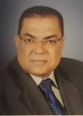
معماري حمدي السطوحي: مهندس إستشاري معماري تخصص مباني عامة "متاحف"، متخصص في الترميم وتأهيل المناطق التراثية، عضو مجلس إدارة جمعية المعماريين، مؤسس حملة أبو سمبل 50، عضو الأتحاد الدولي للمعماريين مجموعة " التراث المعماري – الهوية الثقافية"، مؤسس البرنامج المحلي (AH-CI Egypt) | 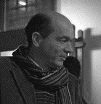
الاستاذ الدكتور حمدي هاشم: خبير دراسات البيئة، حاصل على دكتوراة في الجغرافية البيئية من جامعة القاهرة، وعضو لجنة الجغرافية بالمجلس الأعلى للثقافة، وعضو مجلس إدارة الجمعية المصرية للتخطيط العمراني وكثير من الجمعيات الأخرى، وعضو في بعض اللجان القومية لإعداد استراتيجيات العمل البيئي، وكاتب في مجال البيئة والتنمية في الأهرام والأخبار والنهار اللبنانية والمجلات العلمية والنشر الإلكتروني | 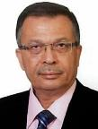
الاستاذ الدكتور خالد الذهبى، رئيس مجلس إدارة المركز القومي لبحوث الإسكان والبناء، ونائب رئيس مجلس البناء الاخضر، عضو العديد من الللجان والهيئات المعنية بأكواد البناء، رئيس العديد من المؤتمرات ومتحدث رئيسي في المؤتمرات الدولية وعضو بالمراكز والمنظمات الوطنية والدولية وخاصل علي تكريم في مصر والعالم | 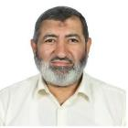
الاستاذ الدكتور خالد عبدالهادي: استاذ العمارة ( تكنولوجيا الحفاظ على التراث المعمارى) بكلية الهندسة بشبرا جامعة بنها،عضو عامل باللجنة الدائمة الآثار المصرية، مدير عام هندسة الآثار المصرية سابقا،عضو المركز المصري الفرنسي لمعابد الكرنك سابقا، استشارى ترميم المباني التراثية بنقابة المهندسين المصرية | 
الدكتورة ريهام عرام: مدير عام ادارة الحفاظ علي التراث بمحافظة القاهرة، دراسات علم الاثار في قسم الإرشاد السياحي بجامعة حلوان حصلت علي للدكتوراة من نفس الجامعة في الحضارة المصرية القديمة و عملت بمجال السياحة لفترة طويلة قبل انضمامها للعمل بمحافظة القاهرة؛ نشرت العديد من المقالات العلمية عن القاهرة التاريخية، كما شاركت في مشروع الاحياء العمراني للقاهرة التاريخية بمرحلتيه الثانية و الثالثة. | 
الدكتور سعد النعيمي استاذ العمارة المبنية والبيئية المشارك: يعمل حاليا في جامعة ديالى بالعراق، أسس قسم العمارة في كلية الفراهيدي وعمل استاذ مساعد في قسم العمارة جامعة البحرين للفترة ٢٠٠٧-٢٠١٤ وعمل في جامعة بغداد، لديه العديد من البحوث في مجال البيئة المبنية وشارك في لجان تحكيم عديدة وعضو في لجان تحكيمية لمسابقات معمارية في الخليج العربي.حاصل على العديد من الجوائز (العراق) | 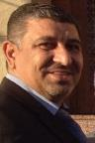
الدكتور سعد مكرم سعد: مدرس بقسم الهندسة المعمارية بجامعة المنصورة،مؤسس لمكتب مكرم للتصميمات المعمارية، قام بتصميم العديد من المشروعات السكنية والتعليمية والتجارية والترفيهية والادارية والطبية وشارك في التصميم المعماري لكاتدرائية العاصمة الادارية الجديدة وتجديد الكاتدرائية المرقسية بالعباسية. | 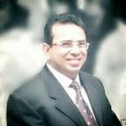
الاستاذة الدكتورة شادية فهيم: عميد كلية الآداب والإنسانيات، الجامعة البريطانية في مصر، حاصلة على جائزة البحوث الممتازة بجامعة عين شمس عن عام 2005، وحصلت على درجة الدكتوراه في الأدب الانجليزي من جامعة إكستير بالمملكة المتحدة عام 1989. | 
الاستاذة صفاء نوار: رئيس تحرير موقع" صدي البلد باللغة الانجليزية"، مدير تحرير موقع صدي البلد الإخباري،مدير تحرير: جريدة الاخبار، رئيس قسم التعليم في جريدة الأخبار، رئيس قسم المرأة في جريدة الأخبار، رئيس تحرير برنامج ناس من بلدنا قناة صدي البلد، رئيس تحرير برنامج م الآخر | 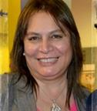
الاستاذ الدكتور صلاح هاشم: أستاذ التنمية والتخطيط بجامعة الفيوم، عمل مراقبا دوليا لاتفاقية مكافحة الفساد فى الأمم المتحدة وممثلا لمصر فى المجلس الدولى للعمل الاجتماعى، له العديد من ال المؤلفات الأكاديمية والثقافية، شارك فى إعداد الإستراتيجية القومية للحماية الاجتماعية بالتعاون مع وزارة التضامن الاجتماعى، والخطة القومية لمكافحة التطرف والفكر التكفيرى بالمجلس الأعلى للجامعات، ومرشح لنيل جائزة الدولة التقديرية فى العلوم الاجتماعية | 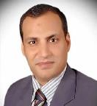
لمهندس طارق النبرواي: نقيب المهندسين الاسبق، كان رئيسا لأتحاد طلاب كلية الهندسة، عمل بشركة المقاولون العرب، اسس جبهة مهندسين ضد الحراسة، وله نشاط وطني وهندسي علي مدار سنوات طويله لها مخرجاتها علي كافة المستويات | 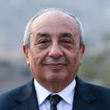
الدكتور عبد الرحيم ريحان بركات ، كبير باحثين بدرجة مدير عام، مدير عام البحوث والدراسات الأثرية والنشر العلمى بوجه بحرى وسيناء، قطاع الآثار الإسلامية والقبطية، وزارة الآثار، له العديد من المؤلفات والكتب، والعديد من المشاركات في شأن الاثار والتراث دوليا وفي مصر، وعضو لجنة الاثار بالمجلس الاعلي للثقافة والعديد من الجمعيات المعنية بالاثار | 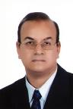
المعمارى المعلم عصام صفى الدين :أستاذ محاضر بكليات الهندسة والفنون والآثاروالسياحة ومعاهد أكاديمية الفنون سابقا وحاليا، مؤسس بيت المعمار المصرى، مؤسس متحف الفنون الشعبية، وله العديد من التصميمات المعمارية المتميزة وكذلك المؤلفات والمبادرات علي مستوي مصر والدول العربية | 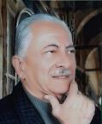
الدكتور عصام العدوي: طبيب عامل في مجال التنمية الدولية ويحمل أكثر ثلاثين عاماً من الخبرة في العمل في البلدان النامية والمتطورة في تصميم وتخطيط وتنفيذ وتقييم المشاريع في مجالات التنمية الاجتماعية والصحة والسكان لكثير من المنظمات الإقليمية والدولية، تصميم وتنفيذ وتقييم برامج لكثير من المؤسسات الدولية مثل الهيئة الألمانية للتنمية واليونيسيف، وبرنامج الأمم المتحدة الإنمائي، صندوق الأمم المتحدة للسكان، مؤسسة فورد، مجلس السكان العالمي | 
الاستاذ الدكتور عفاف بدران: أستاذ مهندس في التصميم البيئي والنقد المعماري، خبرة 35 سنة في تصميم وتنفيذ مشاريع متنوعة في مصر والسعودية، خبرة في التدريس وإعداد البرامج الدراسية المعمارية بالجامعات، خبرة في تحكيم المشاريع، مؤسس مركز درب اللبانة للثقافة والفنون وتنمية البيئة. | 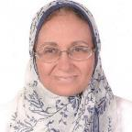
الأستاذ الدكتورعمركرم: عميد كلية علوم الحاسب ونظم المعلومات بالجامعة البريطانية فى مصر، حصل على الدكتوراه فى هندسة الحاسبات من جامعة نورث كارولينا، خبرة مهنية واسعة فى إدارة تكنولوجيا الإتصالات والمعلومات، عمل مديرا لشبكة الجامعات المصرية وشبكة معلومات جامعة عين شمس ومديرا تقنيا لشركة لينك ميدل إيست وكذلك عمل بالمعهد القومى للإتصالات بالقاهرة. | 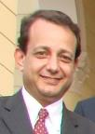
الاستاذ الدكتور علاء الحبشي: أستاذ العمارة والحفاظ على التراث، ورئيس قسم الهندسة المعمارية بجامعة المنوفية، وله العديد من المؤلفات جميعها تهدف لإيجاد آليات حفاظ على التراث تحترم القيم المحلية. وهو عضو في هيئة تحرير مجلة إدارة التراث الثقافي والتنمية المستدامة وأسس مركزًا في القاهرة التاريخية لإعادة إحياء المدن التاريخية. | 
الاستاذ الدكتور علا محمد العجيزي: استاذ اللغة المصرية القديمة ن المتفرغ، كلية الاثار جامعة القاهرة، العميد الأسبق لكلية الاثار جامعة القاهرة، مقرر لجنة الاثار في المجلس الأعلى للثقافةعضو مجلس إدارة المتحف المصري الكبير، امين اللجنة العلمية لترقية الأساتذة والأساتذة المساعدين في الاثار المصرية وتاريخ مصر والشرق الأدنى القديم | 
الأستاذ الدكتور علي أبو غنيمة وحصل على الدكتوراه. من جامعة روما، إيطاليا، 1998، رئيس الملتقى معماريي المتوسط، نائب الرئيس في جامعة ال البيت الاسبق ورئيس قسم الهندسة المعارية بالجامعة الاردنية الاسبق، وقد شغل منصب. مجالات اهتمامه الرئيسية هي تاريخ الهندسة المعمارية والتراث المعماري. مع أكثر من 80 البحوث المنشورة والكتب والمؤتمرات (المملكة الاردنية) | 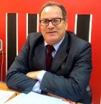
دكتورة غادة قمر: مدرس الجغرافيا و نظم المعلوامات الجغرافية، كلية الآداب جامعة الزقازيق. حاصلة علي الدكتوراة بقسم الجغرافيا، جامعة ليستر بانجلترا في " تطوير المتحف المفتوح بالاقصر و تأثيراتة الاجتماعية- باستخدام نظم المعلومات الجغرافية | 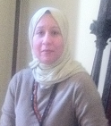
الاستاذة الدكتورة فاطمه البودي مديره ومؤسسه دار العين للنشر ، حاصله علي دكتوراه الكيمياء الحيوية من جامعه عين شمس ، استشاري متفرغ بقسم الباثولوجيا الإكلينيكية بنفس الجامعه . جاء ترتيبها ال ٦٥ من بين اقوي ٢٠٠ إمرأه عربيه في مجال الأعمال حسب تقرير فوربس الامريكيه عام ٢٠١٤. | 
الاستاذ الدكتور ماجد الجمال معماري و خبير عالمي معتمد في التخطيط و التنمية. عمل في حوال عشرة دول عربية و اجنبية و مع مؤسسات حكومية و مشتركة و خاصة و كذلك مع هيئات دولية. من أعماله الاشتراك في تخطيط الآتي، المنطقة الشرقية بالمملكة العربية السعودية و تخطيط إمارة ابوظبي و دولة قطر و الجماهرية الليبية. محاضر و مدرب دولي في اعمال التخطيط | 
المهندس الاستشاري ماجد سامي: رئيس شعبة العمارة بنقابة المهندسين، حاصل علي ماجستير من جامعة اريزونا، عضو مجلس ادارة جمعية المهندسين المعمارين، عضو لجنة العمارة بالمجلس الاعلي للثقافة، عضو اللجنة المفوضة لممارسة المهنة بالاتحاد الدولي للمعماريين | 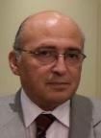
الدكتور محمد ابراهيم يوسف البلقاسي: جامعة ام القرى استاذ مشارك- قسم العلوم الهندسية والتطبيقية- كلية المجتمع بمكة المكرمة، له العديد من الدراسات والمؤلفات والمشاركة في مشروعات الحفاظ والترميم وحقوق الحضارة | 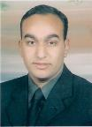
الاستاذ الدكتور محمد محمد الكحلاوي: أستاذ الاثار الاسلاميه بكليه الاثار جامعه القاهره، وكيل كليه الاثار لشئون الطلاب سابقا، رئيس مجلس إداره متحف الفن الاسلامي سابقا، أمين الاتحاد العام للاثاريين العرب، عضو للجنه الخبراء باليونسكو والاليكسو والاسيسكو, عضو للجان تحكيم التراث بالاليسكو، عضو للجنه التظلمات بجهاز التنسيق الحضاري والمباني التراثيه الخاصه لقانون 144 | 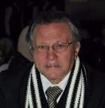
الاستاذ الدكتور محمد جمال عبد المنعم هو أستاذ العمارة ومدير مركز العمارة والتعمير والتراث العالمي (CAUGH) في جامعة نوتنجهام ترنت بالمملكة المتحدة، وعمل في جامعات كوينز بايرلندا وجامعة ويلفرهاملتون في الامارات العربية وله العديد من المؤلفات والمبادرات | 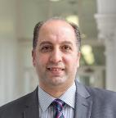
الاستاذ الدكتور محمد شومان أستاذ الاعلام والعميد الموءسس لكليه الاتصال والإعلام بالجامعه البريطانيه وعضو لجنه ترقيات الاساتذه والأساتذة المساعدين بقطاع كليات الاعلام، صدر له ١٦كتابا في الاعلام والراي العام والاتصال السياسي وتحليل الخطاب الإعلامي، شارك في عشرات الموتمرات والندوات الدوليه والعربيه، أستاذ زائر لجامعه استراليا الوطنيه | 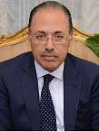
الدكتور محمد علي خليل معماري مصري، مدرس بقسم العمارة والتصميم الداخلي بالكلية العلمية للتصميم بمسقط، سلطنة عمان، ومدرس بقسم الهندسة المعمارية كلية الهندسة جامعة المنصورة بمصر. -دكتوراه في الحفاظ علي المناطق ذات القيمة التراثية من قسم العمارة بجامعة باليرمو بايطاليا. - ماجستير ترميم المباني من جامعة كورب اننا في إيطاليا (عمان) | 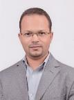
الاستاذ: محمد عثمان سليمان، بكالوريوس اداره أعمال، صاحب مجموعه استونش للسياحه و المراكب التراثيه، مؤسس جمعيه جسر الحضارات للتواصل الثقافي ما بين مصر و العالم، نائب رئيس مجلس إدارة غرفه شركات السياحه سابقا، نائب رئيس جمعية الحفاظ علي السياحه الثقافيه، رئيس لجنة التسويق للسياحه الثقافيه | 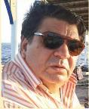
أ.د.محمد عاصم حنفى استاذ العمارة بكلية الهندسة جامعة الاسكندرية - معار الى جامعة بيروت العربية فرع طرابلس – عمل بالتدريس فى عدد من الجامعات بمصر و الامارات و لبنان و له عدد من والمشروعات و الابحاث فى مجالات التخطيط العمرانى و التراث العمرانى و الحفاظ على التراث بالاضافة الى ممارسة المهنة من خلال مكتبه بالاسكندرية | 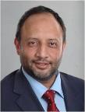
الاستاذ معتصم راشد: المستشار الاقتصادى لاتحاد المستثمرين، عضو مجلس ادارة النساجون الشرقيون، الامين العام لمؤسسة محمد فريد خميس لتنمية المجتمع، عضو المجالس القومية المتخصصة ( الشئون المالية والاقتصادية )، وكيل وزارة ( الهيئة العامة للاستثمار والمناطق الحرة . جمعيات المستثمرين والمنظمات الدولية ) سابقا. | 
الدكتور مدحت عنمان: معماري حاصل علي الدكتوراه من الممكلة المتحدة ونظم ادراة البيئة، عضو الجمعية البريطانية للتصميم الدولي، وعضو مجلس ادارة خريجي الجامعات البريطانية في مصر لعدة دورات وحاصل علي عدد من الجوائز في التصميم المعماري | 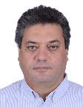
الاستاذ محمود السقا: مدير عام ورئيس قطاع الاستثمار وتمويل الشركات بالبنك العربي الافريقي الدولي، رئيس جمعية الخريجيين والمتدربين من الجامعات البريطانية في مصر، ماجستير من جامعة ويلز ودراسات بجامعة هارفارد ونائب رئيس الجمعية المصرية للدخل الثابت، عضو مجلس ادارة الجمعية المصرية لأدارة الائتمان والمخاطر | 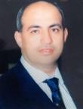
الاستاذ الدكتور محمود المليجي: أستاذ الهندسة الجيوتقنية و الاساسات، نائب رئيس جامعة المنصورة لشئون خدمة المجتمع و تنمية البيئة، عميد كلية الهندسة جامعة المنصورة سابقا، رئيس قسم الهندسة الإنشائية كلية الهندسة جامعة المنصورة سابقا، المستشار الهندسي لمحافظ الدقهلية سابقا | 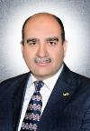
الدكتورة مني يحيي: مدير عام الشئون الفنيه بمكتب برأت الاختراع خبير في مجال براءات الاختراع لدى المنظمة العاالمية للملكية الفكرية وكبير مدربي الاكاديميه الوطنيه للملكيه الفكريه وخبير ببرنامج الأمم المتحدة للتنمية في مجال براءات الاختراع حاصله على ماجستير ميكروبيولوجي من الاكاديميه الطبيه العسكريه واصله على دبلوم اداره من الجامعه الامريكيه.
الدكتورة مى وهبه مدكور: منسق عام برنامج هندسة العمارة البيئية ومدرس العمارة بكلية الهندسة جامعة طنطا، عملت بالعديد من الجامعات والمعاهد التعليمية. تخرجت من قسم الهندسة المعمارية جامعة المنصورة عام ١٩٩٩ وحصلت على درجتي الماجستير والدكتوراه من عمارة المنصورة. | 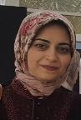
الاستاذ الدكتور ميسون النهار، عميد كلية الآثار والسياحه بالجامعة الأردنيه سابقا وحاليا اجازة تفرغ علمي في جامعة كولون / المانيا، مديرة متحفي الآثار و التراث الشعبي ، معهد الآثار ، الجامعة الأردنية. مديرة مشروع تنقيبات موقع تل ابو الصوان (العصر الحجري الحديث) ،جرش، مشروع تدريبي لطلبة الجامعة الأردنية . ومنسقة البحث العلمي في الجامعة الأردنية لمشروع متحف الأردن. (المملكة الاردنية) | 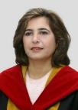
الدكتورة.نهى عباس حسين: طبيبة اسنان وكاتبة اطفال ومنتج فنى متخصص فى الانتاج الفنى للطفل، رئيسة تحرير مجلة نور للاطفال الصادرة عن المنظمة العالمية لخريجى الازهر، مؤلفة مسلسل نور وبوابة التاريخ الحاائزة علي جائزة محمد بن راشد | 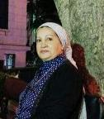
المعمارية: هاله علي حسنين مؤسسة موقع العمارة والتراث والاستدامة، حصلت على دورة تدريبية في الترجمة من وإلى اللغة الانجليزية من مركز اللغات المتخصصة، جامعة القاهرة، عملت بهيئة التخطيط العمراني ثم في مجال الترجمة في مجال العلوم والمعرفة، وحاليا في مجال الحضارة والتراث. | 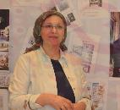
الاستاذ الدكتور هشام خيري إستاذ العمارة، كلية الهندسة، جامعه القاهرة و الأستاذ الزائر بجامعة كاليفورنيا و مهندس معماري ومخطط حضري لديه خبرة تزيد عن 25 عامًا في عمليات التطوير العمراني و الحفاظ الحضري والتاريخي . د. عيسى حاصل علي شهادة دكتوراه مشتركة في التخطيط العمراني من جامعة كاليفورنيا ، بيركلي وجامعة القاهرة ، وماجستير في الهندسة المعمارية من جامعة القاهرة. (الولايات المتحدة الامريكية) | 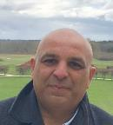
الاستاذة الكاتبة الصحفية هدايت عبد النبى: رئيسة مجلس إدارة ورئيسة تحرير مجلة "حقوق الناس"، *نائبة رئيس جمعية العاملين الدوليين السابقين بالأمم المتحدة (أفيكس مصر)، عضوة مجلس إدارة الاتحاد النوعى لنساء مصر، رئيسة تحرير مجلة "ما بعد" الفصلية، التى تصدر عن أفيكس مصر، وريئسة الحملة الدولية لحماية الصحفيين ومقرها جنيف | 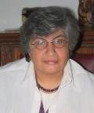
الدكتورة هويدا صالح: أستاذ مساعد الأدب العربي بكليتي الألسن والإعلام بجامعة مصر الدولية، رئيس تحرير مجلة مصر المحروسة التي تصدرها وزارة الثقافة المصرية، مدير المركز الإعلامي بأكاديمية الفنون، لها العديد من المؤلفات الابداعية والنقدية، المشاركة في تحكيم العديد من المسابقات المحلية والعالمية مع المشاركة في العديد من المؤتمرات في مصر والعالم العربي | 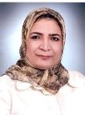
الاستاذ الدكتور وائل يوسف: أستاذ العمارة والتخطيط العمراني، كلية الهندسة جامعة الأزهر، مراجع معتمد بالهيئة القومية لضمان جودة التعليم والاعتماد، شارك في العديد من المشروعات البحثية والأنشطة العلمية والأعمال المهنية في مجال التخطيط العمراني والإسكان والعمارة داخل مصر وخارجه. | 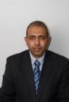
الأستاذ الدكتور ياسر صقر أستاذ العمارة كلية الفنون الجميلة ورئيس جامعة حلوان السابق، تقلد العديد من المناصب الأكاديمية والادارية وحاصل علي الدكتوراة من جامعة ميتشجان بالولايات المتحدة، له العديد من الأبحاث العلمية المنشورة في مجالات العمارة والعمران حاصل علي العديد من الجوائز وتم تكريمه من العديد من المؤسسات العلمية، قام بالاشراف علي ومناقشة العديد من الرسائل العلمية بجامعات مصر وأوربا. | 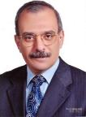
الدكتورة ياسمين صبري حجازي: قائم بأعمال رئيس قسم العمارة جامعة الزقازيق، عضور المجلس الاعلي للثقافة لجنة الاثار، لها الكثير من مشروعات الحفاظ تصميم وتنفيذ والمشاركة في متحف الحضارة، ولها مشاركات مجتمعية بالقاهرة التاريخية وعددا من المؤلفات والدراسات في الحفاظ والسياحة والعمارة | 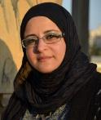

4. Developing and distributing different types of outreach materials to raise awareness
Civilization Rights to Build Civilization Campaign
During the past year FECSFS invested considerable efforts in developing materials to reach out the largest possible number of audience across all sectors. Examples of the materials included:
- Flayers in both Arabic and English about the campaign goals and ways to participate.
- Short animated videos (in Arabic and English) explain the campaign and the competition
- A series of short YouTube episodes explaining concepts related to the civilization rights (posted on various groups on Facebook and other social media outlets)
- A live broadcast to answer direct questions about the campaign and the competition
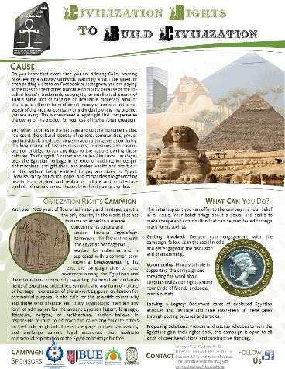
Example of a Brochure Developed for Egyptian/American Highschool Student Delegates
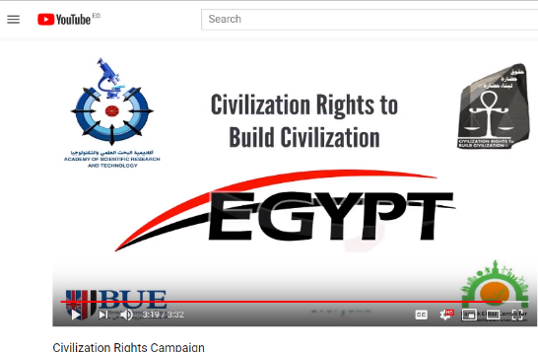
Screenshot of a YouTube video developed to introduce the campaign in English (available on: https://www.youtube.com/watch?v=VDtStlsb1Fs)
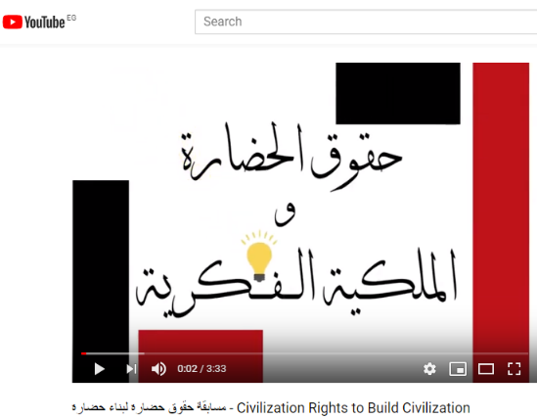
Screenshot of a YouTube video developed to introduce the Civilization Rights competition in Arabic (available on: https://www.youtube.com/watch?v=QLNLq5gdXyo)
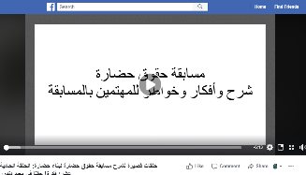 | 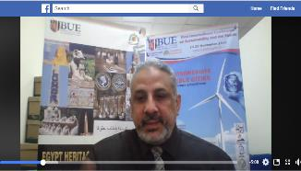
A screen short of 1 of 15 six-minute videos delivered by Professor Ahmed Rashed o Facebook to explain the Civilization Rights Competition – All videos can be found on https://www.facebook.com/pg/civilizology/videos/

5. Organizing and Announcing a National Competition
Civilization Rights to Build Civilization Competition
FECSFS organized a national competition to solicit innovative ideas capable to deal with the cases of exploitation of the Egyptian heritage and propose mechanisms and practical applications regarding the intellectual rights of Egypt. The competition was made open to all individuals, universities, institutions, companies and bodies operating in the Arab Republic of Egypt to provide suggestions and ideas concerning possible dealing with one of the cases through which the profit from the heritage of Egyptian civilization, for example -but not limited to-:
- International museums or exhibitions displaying original Egyptian heritage and artifacts.
- Profit projects based on a heritage of the Egyptian civilization, such as Luxor Casino in Las Vegas.
- Companies or factories based on the reproduction and sale of a heritage derived from the Egyptian civilization (souvenirs, statues, video games, etc.).
- Each presentation should include a systematic study to deal with one of these cases by documenting the situation and determining its importance as well as characterizing the legal, cultural, financial and ethical dimensions of exploiting the Egyptian heritage, and then proposing a framework for dealing with this situation and a mechanism to implement the proposed solution Intellectual property, all in accordance with the rules governing the competition.

Awards offered:
- 40 thousand pounds for the first place.
- 20 thousand pounds for the second place.
- 10 thousand pounds for the third place.
- 5 thousand pounds for the fourth, fifth and sixth.
On the 19th of November 2018, it was officially announced a press conference held at the headquarters of the Academy of Scientific Research and Technology in cooperation with the British University In Egypt and Farouk Al-Baz Center for Sustainability and Future studies and was in the presence of Prof. Ahmed Hamad, BUE President, Prof. Mahmoud Sakr, President of the Academy of Scientific Research, the main researcher of the campaign and director of the Farouk El-Baz Center for Sustainability, Dr. Ahmed Yehia Rashed, in the presence of a number of media leaders and Researchers.
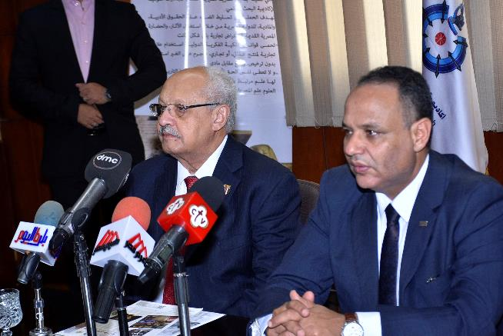

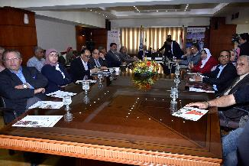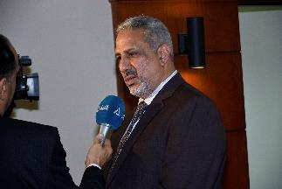
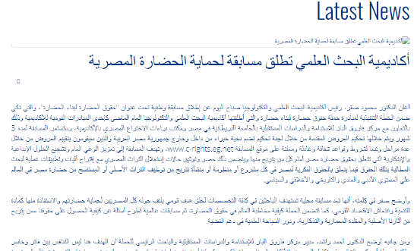
Screen shot of the announcement posted on the ASRT Website
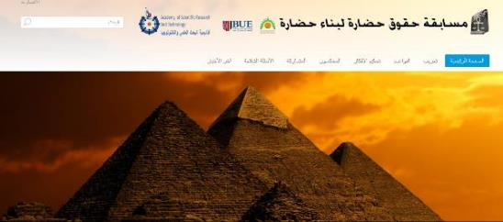
Screen shot of the competition website ( http://www.c-rights.eg.net/index.php/ar/)

6. Organizing a Workshop for the Competition Contestants
Civilization Rights to Build Civilization Competition
FECSFS organized a workshop for the contestants of the civilization rights competition on April 13, 2019, at BUE. About 90 participants attended the workshop from all around Egypt as well as staff members from faculty of engineering, multiple students and some of the Juries of the competition. The day started with an opening talk given by Prof. Ahmed Rashed -the PI of the Civilization Rights to Build Civilization campaign. He covered in his talk aspects related to the campaign and its mission and goals and the agenda of the workshop. Each participant then presented his/her idea within 5 minutes. 42 ideas were presented out of total of 56 ideas submitted to the competition. At the end of the workshop, it was decided that for the second phase of the competition the participants should collaborate to complete their ideas with different views to achieve perfection of it so that it can be demonstrated later in the USA tour of the campaign.

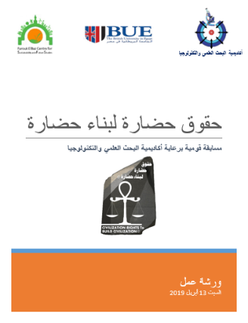 | 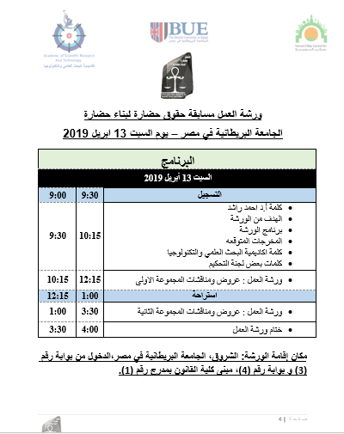
Workshop Agenda
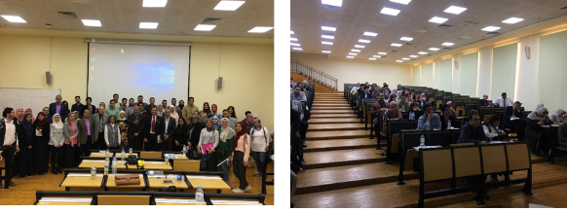
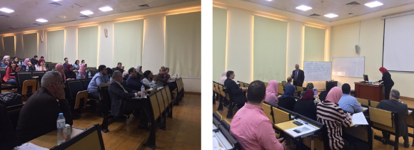
Pictures of some of the contestants presenting their works

9. Colloboration

FECSFS
Collaborators | 2018/2019
Organization | Data of Signed Agreement | Nature of Collaboration
ASHRAE – BUE - collaboration with FECSFS | 2019 | ASHRAE Society for the Civilization Rights Competition
Cairo Governorate | 2018 | The conservation and adaptive reuse for the heritage ministerial buildings after moving to the new Capital
Academy of Scientific Research and Technology | 2018 | Scientific Collaboration during Green Heritage Conference
Housing & Building National Research Centre | 2018 | Scientific Collaboration during Green Heritage Conference
National Research Institute of Astronomy and Geophysics (NRIAG) | 2018 | Scientific Collaboration during Green Heritage Conference
Nottingham Trent University | 2018 | Scientific Collaboration during Green Heritage Conference
University of Leeds | 2018 | Scientific Collaboration during Green Heritage Conference
Leeds Beckett University | 2018 | Scientific Collaboration during Green Heritage Conference
Northumbria University | 2018 | Scientific Collaboration during Green Heritage Conference
King Saudi University | 2018 | Scientific Collaboration for Red Sea Development
HBRC | 2017 | the Green Worship Competition
ASRT | 2017 | “Civilization Rights Campaign”

10. Center Activities
1. FECSFS Website
http://www.bue.edu.eg/index.php/csfs-home##
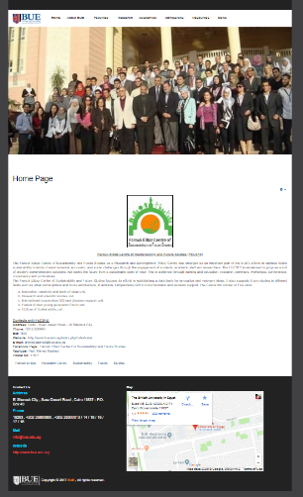

2. Official Facebook Page
https://www.facebook.com/FECSFSBUE/
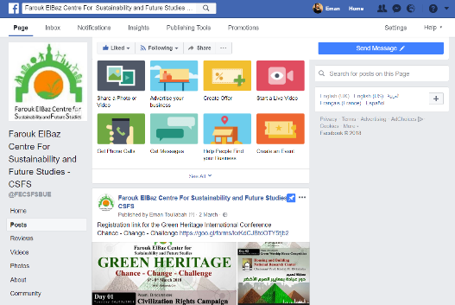
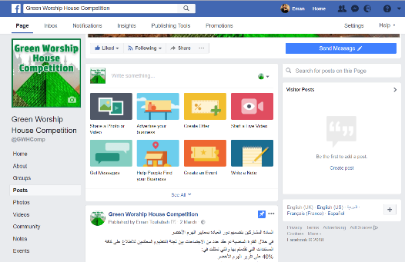

3. Civilization Rights Ambassadors on social networking sites Facebook
https://www.facebook.com/FECSFSBUE/
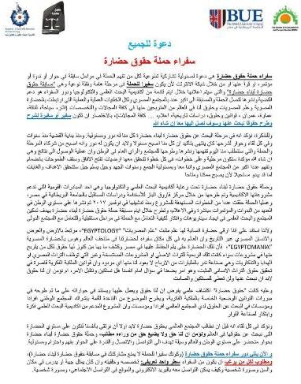
It was published to invite the ambassadors of Civilization Rights Campaign on the social networking Facebook sites, which aims to expand the supporters’ base campaign with different age groups as well as different disciplines. And focuses the role of ambassadors of civilization's rights campaign in support of the case and published until the campaign reaches the largest possible number of citizens with This is a good response from the leaders of the social networking site Facebook, and this is evidenced by the number of those who sent positive comments and offered their participation and full support of the issue.

4. D. Creating a page for the campaign of the rights of civilization on the website "Wasal”
Wasl-eg.com
A number of campaign supporters have created a page for the Civilization Rights campaign on the Wasl-eg.com website. This page deals with all the news, events and issues related to the campaign.

5. Signed contract with ASRT for the design of the website of the contest rights of civilization ”
http://www.c-rights.eg.net/index.php/ar/
The workshop team met with the officials of the Scientific Research and Technology Academy. A meeting was held with Mr. Khalid, who is in charge of the academic network. A detailed explanation was given by Mr. Ahmed Rashid about the campaign and the proposed vision of the website and the information it should contain. Site. Mr. Khalid then asked for some data and information to be published on the contest website.
In terms of administrative and financial aspects, a contract was signed between the British University represented by Farouk El-Baz Centre for Sustainability and Future Studies and Director of the Information Network of the Academy of Scientific Research and Technology, explaining the role that will be played by the network of information and financial burdens that will be borne by the campaign to implement the campaign website.
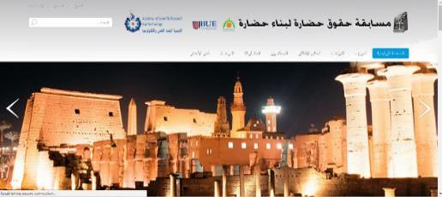
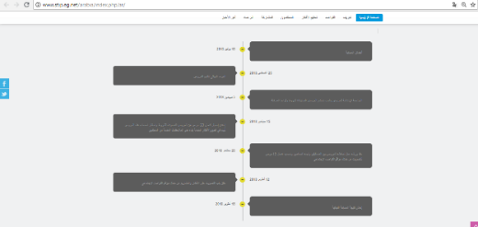
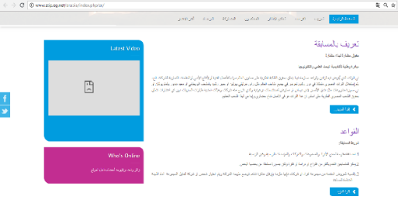

6. Dr. Hesham Safwat Activities Related to the center
ASHRAE
- Award winning competition for air-conditioning bed project year 4 mechanical 2019 in ASHRAE HVAC competition 2018-2019 for universities
- ASHRAE – BUE - seminar in British university hall with the collaboration with FECSFS and announcement for ASHRAE society for the civilization rights competition
- ASHRAE word society interview for Dr Farouk Elbaz and the role of sustainability in new societies with his historian life interview
- ASHRAE director region Dr Ahmed Alaa meeting with Dr Farouk for future potential cooperation with FECSFS centre and capability of doing MOU agreement.

7. Future plans and Next steps for FECSFS
Plans for 2019/2020
- Civilization Rights Competition Results during the Final Conference of the National Campaign of Civilization Rights that will take place in October 2019.
- Tour conducted by Professor Ahmed Rashed in the USA (July & August 2019) to discuss the results of the national campaign with American institutions
- Planning for the next funding phase of the Civilization Rights project with ASRT
- Target external funding
- Civilization Rights Conference, 2019, Cairo: كيف يمكن تأسيس علم حقوق حضارة؟ (See below more details)
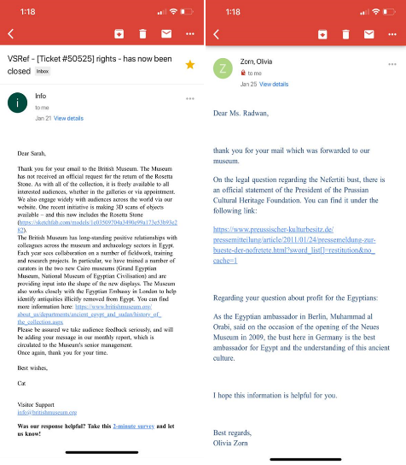
Topic Titles:
- Civilization rights and law
- Civilization rights and archaeology
- Civilization rights and tourism
- Civilization rights and environmental concern
- Civilization rights and new museology
- Civilization rights and architecture
- Civilization rights and democracy in action
- Civilization rights and development and construction
This conference will be held to support the master’s thesis and all studies will be cited as a reference and used for scientific reasons only.
About the conference:
" The underestimation of history will inevitably be followed by a concession in geography” The director of Farouk ElBaz Centre of Sustainability and Future Studies (FECSFS), Prof Ahmad Rashed made this plea for retrieving Egyptian civilization rights. civilization right is a new standard for “human rights”. Civilizations have influenced humanity over the last centuries leading to the current situation. Accommodating change and participating in the process of regaining the rights of many civilizations that have been torn through decades should be an international norm for people to consider. This conference is a major macro-level investigation of civilization rights and its main-related approaches.”

11. Finance
FECSFS
Summary Budget |  | 2018/2019
2018/2019 Approved Budget | Spending |  | Balance
Human Resources | 2 Research Assistance |  | EGP 84,000.00
Equipment | Farouk El-Baz Shipment |  | EGP 42,264.64
Technical Service
Consumables
Activities | Workshop (Civilization rights competition) |  | EGP 1,407.81
International Visitors
Travel (not common)
 | TOTAL |  | EGP 127,672.45

Annex

Enclosed are the Quarterly Reports (In Arabic) from the Civilization Rights to Build Civilization Project that were prepared and submitted by FECSFS to ASRT. They are provided as a separate file because of the large size of the files.

